Easy Access-Low Traffic

Jay W. Zea

ABR, CLHMS, CRS, SRS, PSA
RE/MAX Professionals, Inc.
606 W. 33rdStreet, Sioux Falls, SD
Direct Line – (605) 376-6471
Email – jay@jayzearealestate.com
Or Visit My Website at – www.jayzearealestate.com

*Price : $9.50 psf
*Type: NNN ($4.26 psf)
*Zoning: C-2
*Heat / A/C: Gas/Electric
*Suite Size: 1747 sq ft (rentable)
*Loading: Passage door only
*Floors: Carpet
*Roof: Rubber
*Windows: Yes-Operable
*Parking: Ample
*Restrooms: Common (ADA)
309 W 43rd Street
Suite 103

BUILDING FEATURES

Move in ready office space at a reasonable price!! Four private offices with operable windows, reception, conference room plus large open area for work space or cubicles.

Ample “free” parking on-site and monument sign on 43rd and building signage available.

Monthly Rent Breakdown Estimates
Base: 1747sqft x $9.50 = $1660.00
NNN: 1747sqft x $4.26 = $ 620.00

Total: $2280.00 per month + Utilities

REMARKS

Information herein deemed reliable but not guaranteed

LOCATIONAL FEATURES

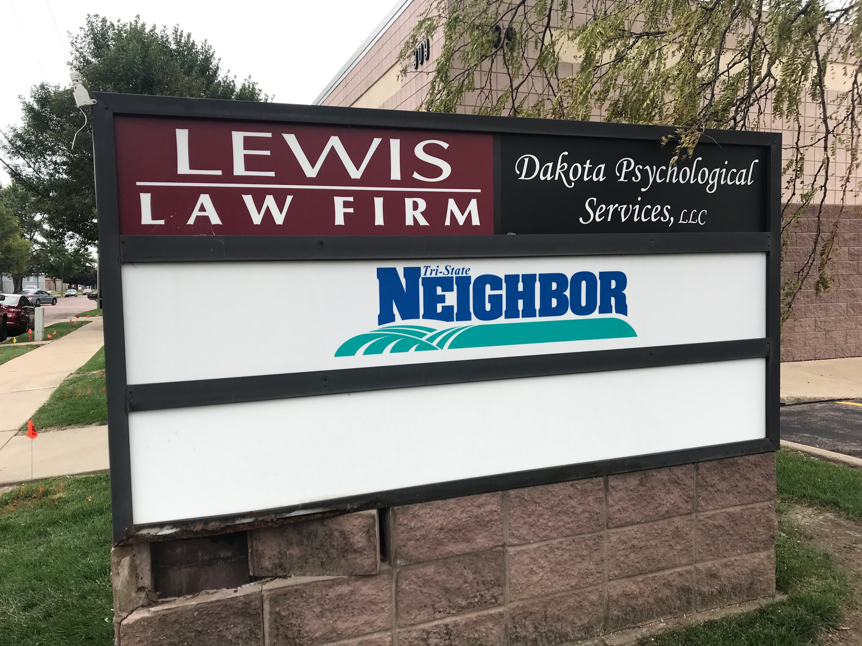
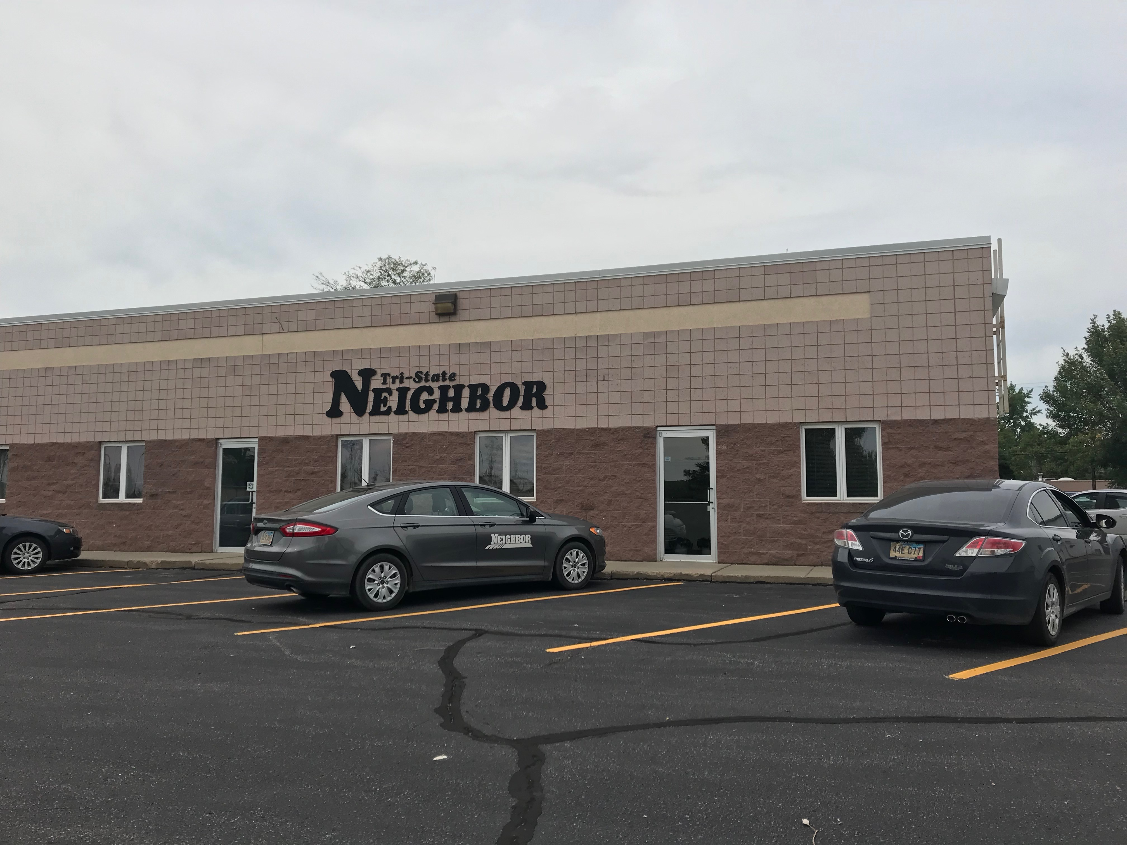
For Lease

