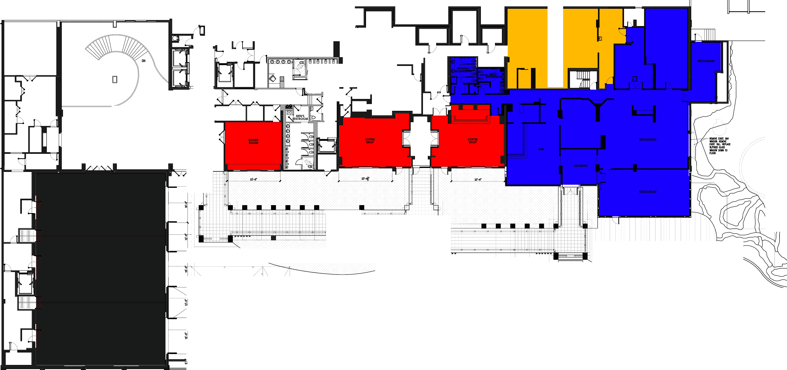
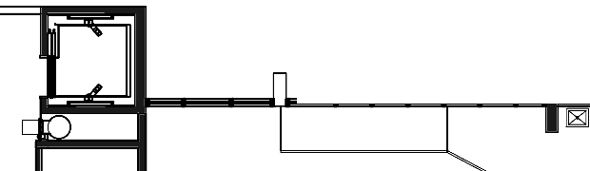


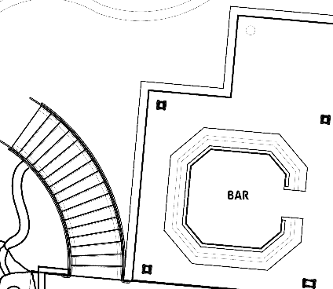
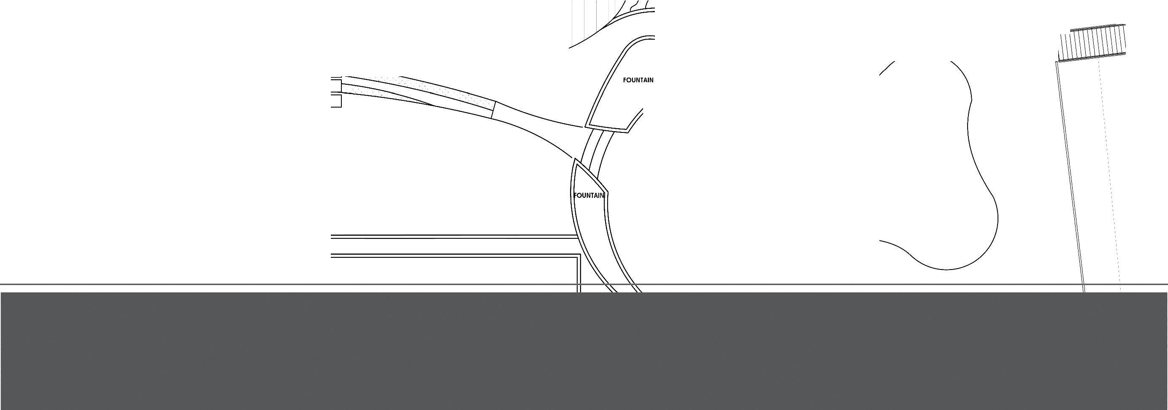
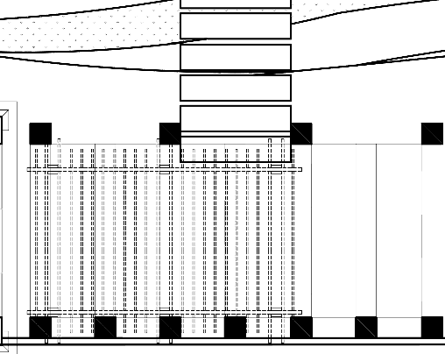


SERVICE
-
PANTRY
I

KITCHEN

□ ......

PRE-ASSEMBLY
ELEVATOR
LOBBY

□ □

WOMEN'S
RESTROO�M�=='.
□

ICITCHEN

J
LOWER
POOL

'
I

1.. , .. , , .

:E>VERED--- REEZE--WAY-

RETARAT ER ACE
11
1/
I
,,'I
I

'I'
)
11
I,

""""'"""'"'·""

FUNCTION

TERRACE

1- I
UTOOOR
Kl CHEN/BAR
I
I

FUNCTION

TERRACE

UPPER
POOL DECK

UPPER
POOL

o
PLANTER

