6181 Thompson Road, Suites 700.

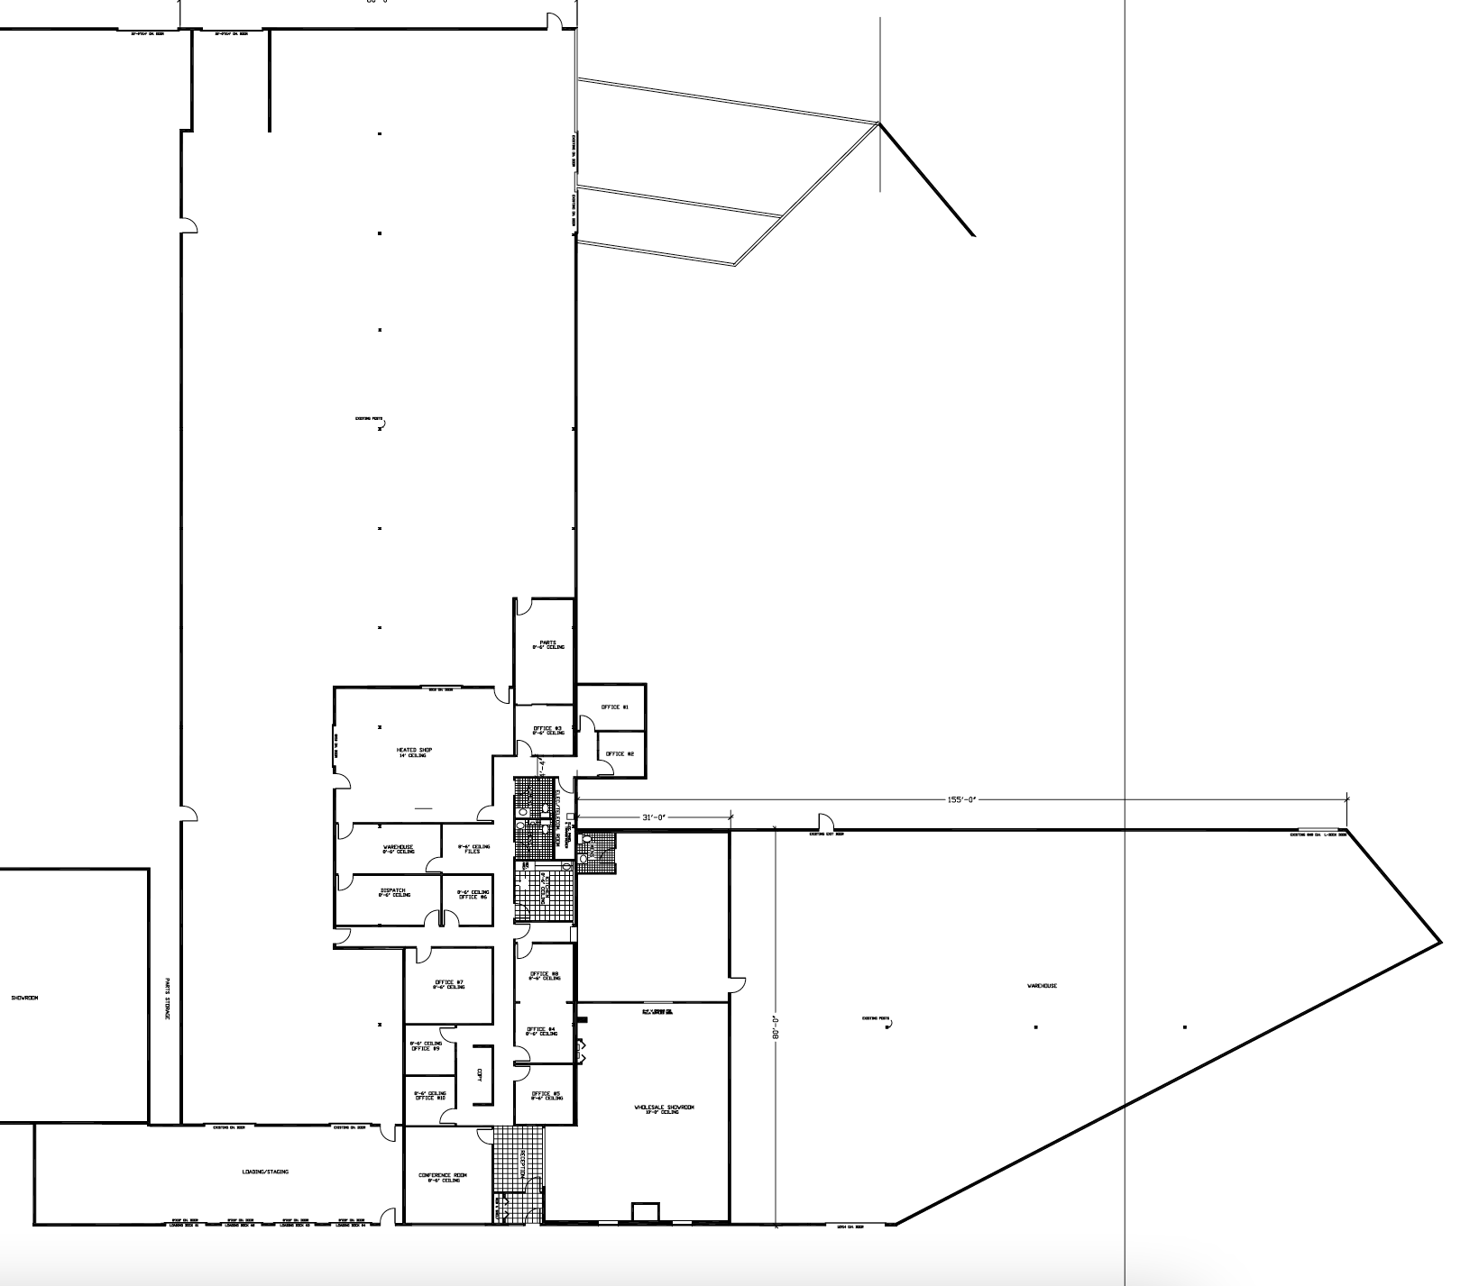

All information furnished, regarding property for sale, rental or financing is from sources deemed reliable, but no warranty or representation is made to the accuracy thereof and same is submitted subject to errors, change of price, rental or conditions prior to sale, lease or financing or withdrawal without notice.

