2 spaces for lease, each with approximately 800 SF.
Big parking lot with incredible signage!!!
READY FOR OCCUPANCY NOW!
5520-38 Del Amo Blvd., Lakewood, CA

Suite A - $1,350 per month
Suite C - $1,260 per month
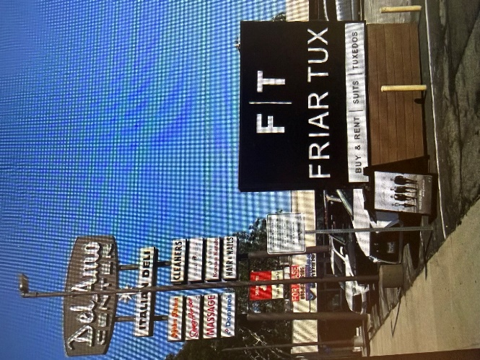
Prime location – private bathroom - strong income area –restaurants, etc.
2,3 or 5 year lease, your choice
Call or text Joe at 818 635 2105

