
VIA EMAIL doug.holtzman@tscg.com and danielle@primericagroupone.com Wednesday, February 26, 2025
Thursday April 3, 2025

Thursday, June 12, 2025

Mr. Doug Holtzman
Vice President
TSCG LLC
4200 W Cypress Street, Suite 780
Tampa, Florida 33607
Ms. Danielle Trzcinski
Leasing & Sales
GATEWAY COMMONS EAST LLC, C/O Primerica Group One
3629 Madaca Lane
Tampa, Florida 33618
RE: Proposed Purchase Agreement
9690 Buffalo Road (OP 5), Palmetto, FL 34221
Sarasota-Bradenton, FL MSA, Manatee County
649010909
0.76 Acres, 110 Feet Frontage and 301 Feet Depth
Mr. Doug Holtzman and Ms. Danielle Trzcinski:
The purpose of this Letter of Intent (“Letter”) is to document the agreement between GATEWAY COMMONS EAST LLC, C/O Primerica Group One (“Seller”) and an Independent Licensees of Valvoline Instant Oil Change Franchising, Inc. (“Buyer”) with respect to certain business terms to be included in the Purchase and Sales Agreement (“P&S”) substantially in the form of the Buyer’s P&S agreement. Seller and Buyer understand that the P&S will contain additional terms and legal rights that are important to the parties and are more suitable to be addressed in the P&S. Seller and Buyer each warrant the following:
(1) This letter has been signed by Seller’s and Buyer’s authorized representatives.
(2) Seller and Buyer have agreed to the terms set forth in this Letter with the understanding that these terms will be included in the P&S.
(3) Neither Seller nor Buyer will seek to change the terms contained in this Letter during the P&S negotiations.
Seller and Buyer further agree to negotiate in good faith to resolve terms in the P&S not set forth in this Letter. Specifically, Seller and Buyer will use diligent efforts to execute a final P&S within thirty (30) days after the date Seller and Buyer sign this Letter. This letter does not constitute a P&S, nor is this Letter intended to entitle Seller to any compensation at this time from Buyer or to grant Buyer any rights to Seller’s real estate.

1. BUYER: | TBD, an Independent Licensees of Valvoline Instant Oil Change Franchising, Inc.
2. SELLER: | GATEWAY COMMONS EAST LLC, C/O Primerica Group One or Owner of Record
3. PROPERTY: | Approximately 0.76 Acres or 33,110 square feet net usable land situated off of Moccasin Wallow and Buffalo Roads Fully Signalized Intersection Directly North, Manatee County, FL,– currently unencumbered, being more particularly described on Exhibit "A" attached hereto and made a part hereof by this reference.
4. PROPOSED BUILDING: | Buyer shall occupy a building that is approximately 1,900 square feet (62 by 30 FT), which shall include 12 FT / 2 Bay drive throughs and meet the criteria for the current Valvoline Instant Oil Change Franchising, Inc. Site plan needs to be approved by Seller to fit existing utility easements.
5. PURCHASE  PRICE: | $1,250,000 cash at closing. Fifty-Five Thousand Dollars ($55,000) shall be deposited with Seller’s attorney title company within five (5) business days following the execution of a Real Estate Contract, which shall be applicable to the Purchase Price but refundable if Buyer is unable to obtain Permits per the Permitting Period detailed below.
6. INSPECTION PERIODS: | Buyer shall have Sixty (60) days from the date of final execution of the Purchase and Sales Agreement to inspect the Property (”Inspection Period”) and related documentation to ensure the Property is suitability for Buyer’s use as a quick service automotive lube & repair facility (“Intended Use”) with up to 1,900 square feet, and shall have the right to terminate the Purchase and Sales Agreement at any time prior to the expiration of the Inspection Period by written notice to Seller. Within five (5) days from the effective date of the Purchase and Sales Agreement, Seller agrees to provide Buyer all due diligence information, in Seller’s possession such as but not limited to: Plan(s), survey CADD of Property, any other building plans, engineering and environmental reports/studies, soils report/study and Reciprocal Easement & Restrictive Agreement (REA), Form W-9 - Internal Revenue Service survey, existing title policy/report and all other information pertinent to this transaction.
7. PERMITTING PERIODS: | From expiration of Inspection Period Buyer shall have one hundred eighty (180) days to obtain site plan approval and all necessary building permits for Buyer’s intended use (“Buyer’s Permitting Contingency Period”). Buyer shall use all reasonable efforts to obtain such permits. Buyer shall have the right for good and satisfactory reasons to extend Buyer’s Permitting Contingency Period, provided Buyer timely submits for such permits and diligently pursues during the initial Buyer’s Permitting Contingency Period unless otherwise provided for herein. If all Permits are not obtained by the end of the Initial Permitting Period, and provided Buyer timely submitted for and diligently pursued obtaining the Permits, Buyer shall have the right to extend the Initial Permitting Period for three (3) additional thirty (30) day periods (such additional periods, the “Extended Permitting Period”) as needed in order to obtain such Permits, by providing written notice and twenty-five thousand ($25,000) dollars for each extension period to Landlord of such extension prior to the expiration of the then current Permitted Period, said extension fees shall be applicable to the purchase. If buyer requires up to three (3) additional extensions, cost will be twenty-five ($25,000) dollars for each extension period and applicable to purchase price. In no event shall the Permitting Period extend beyond the date which is three hundred sixty-five (365) days following the Effective Date of the Purchase agreement.
8. CONDITION OF PROPERTY: | Seller shall provide the Property in the following condition (Seller’s Work):  - Property delivered unencumbered cleared, filled and compacted, brought to subbase grade with engineered fill and in an environmentally clean condition.  - Seller, at Seller’s expense, shall provide and install all necessary public utilities within 5 feet of the Property boundary adequate for Buyer’s intended use; internal roads as depicted on Exhibit B. Buyer shall pay customary hook up charges and impact fees.  - Seller shall provide, at Seller’s expense, off-site retention with drainage transmittal lines within 5 feet of the Premises boundary adequate for Buyer’s intended use with the necessary capacity for Buyer’s storm water management (not to be located on the Property).  - Free and clear of any environmental conditions with all documentation from the appropriate governmental authorities clearing the Property Premises of any environmental conditions.
9. CLOSING: | Closing shall be within 30 days of completion of Seller’s work and receipt of all non-appealable governmental approvals and permits for the construction of a current prototypical Valvoline Instant Oil Change facility.
10. CLOSING COSTS:  11. PERMIT/  IMPACT FEES: | Buyer will pay taxes and recording fees on notes, mortgages and financing statements and recording fees for the deed. Seller will pay taxes on the deed, recording fees for documents needed to cure title defects, real estate commission and Buyer’s Title Policy. If Seller is obligated to discharge any encumbrance at or prior to closing and fails to do so, Buyer may use purchase proceeds to satisfy the encumbrances.  Buyer is responsible for, and shall pay, all permit and impact fees, or similar fees and expenses that may be assessed for Buyer’s construction or occupancy. Seller may have certain Transportation impact fee credits (the “Impact Fee Credits”) available which can be assigned to Buyer’s impact fee obligation in connection with the construction of the Premises. In this regard, to the extent Seller has any Impact Fee Credits available that may be used by Buyer to offset Transportation / Mobility impact fees that will be payable in connection with Buyer’s construction, then Buyer shall purchase (and Seller shall irrevocably transfer) such Transportation / Mobility Impact Fee Credits on or before such time as the payment of said impact fees is required of Buyer. (Fees are typically due prior to a Certificate of Occupancy is issued). Seller estimates Buyer’s Transportation / Mobility Impact Fees (based on 1900 sf building) to be twenty-two thousand three hundred and 30/100’s ($22,300.30). Post September 8, 2025, Manatee County Impact Fees are scheduled for an increase. The estimated impact fees for 1,900 sf as of September 9, 2025 is anticipated to be approximately $53,245.60.
12. CONTINGENCIES: | The Closing shall be contingent upon, but not limited to the following:  - marketable Title;  - acceptable survey;  - clean Environmental;  - acceptable zoning;  - property free of all tenancies;  - Approval by Valvoline Corporate Approval Committee and all other necessary ancillary associated studies and approvals which contingency must be satisfied or waived on or before expiration of the Inspection Period;  - Buyer shall be allowed the maximum signage as allowed by the existing sign code, or as allowed by any variances Buyer may obtain by approval of the City/County, including, but not limited to, a reader board pylon and/or monument sign on the out parcel, building signage, and directional signage;  - Receipt of all necessary permits and approvals for the use of the Property for Buyer’s intended use without unusual or extraordinary expense.
13. RIGHT TO ENTER:  . : | Buyer and Seller are negotiating the potential sales of the Property by Seller to Buyer. To allow Buyer to proceed with its due diligence with respect to the Property, upon execution of a Purchase agreement, Seller hereby agrees to allow Buyer to enter the Property to conduct any and all reasonable tests and investigations with respect to the Property, including surveys, soils tests and environmental tests and investigations. All such tests and investigations shall be conducted at the sole cost and expense of Buyer. Buyer agrees to restore any portion of the Property disturbed in connection with any such tests and investigations conducted by Buyer.  Buyer agrees to indemnify and hold Seller harmless from and against any and all loss, cost, claim, damage or expense arising out of or due to any entry on the Property by Buyer, its employees, agents or contractors.  In the event negotiations between Buyer and Seller cease, this Letter of Intent is not binding and may be terminated by Seller upon twenty-four (24) hours prior written notice, to Buyer.
14. REAL ESTATE BROKERAGE COMMISSION: | Seller agrees to indemnify and hold Buyer harmless from any and all claims or damages brought about by any broker or firm. Buyer warrants that it has not had contact with any broker except TSCG LLC. Any brokerage commissions shall be paid by Seller directly to broker, per separate agreement.

The Purchase and Sale Agreement shall incorporate the terms and conditions of this letter of intent as refined by negotiations and drafting, together with such other terms and conditions requested and acceptable to the parties hereto. The above terms are communicated to you so that if a mutual agreement can be reached on the terms as set forth herein, both Buyer and Seller can proceed to prepare, anticipate and finalize a definitive Purchase and Sale Agreement.
If the above terms are acceptable to you, you agree not to negotiate with any third party respecting the sale and/or lease of the property for a period of thirty (30) days hereafter. Provided, Purchase and Sale Agreement to be presented to Seller within ten (10) days and fully executed by both parties within the following twenty (20) days. Parties need to be negotiating in good faith. Except for such limitation within the thirty (30) day period following the acceptance of this letter of intent shall not, and should not be constructed, to create or bind either Buyer or Seller to any obligations, legal or otherwise, respecting the Property, but is intended only to determine whether there is a basis acceptable to Buyer and Seller for proceeding toward a legally binding definitive Purchase and Sale Agreement for the sale of the Property.
Please evidence your acceptance of the terms hereof by execution of the enclosed counterpart of this letter and return of same to Buyer. Buyer shall evidence acceptance of the terms hereof by execution of this Letter of intent no later than 5:00 p.m. EST, Wednesday, June 18, 2025.

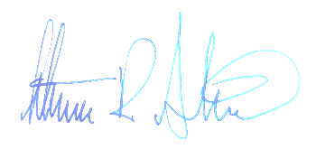
Sincerely,
Steven R. Jenkins
Real Estate and Business Development

AGREED TO AND ACCEPTED BY SELLER THIS ______ DAY OF _____________, 2025.

By:

Title:

Doug Holtzman (330) 760 - 2647

Danielle Trzcinski (813) 933 - 0629

Exhibit A

9690 Buffalo Road (OP 5), Palmetto, FL 34221
Sarasota-Bradenton, FL MSA, Manatee County
Purchase Agreement for 12 FT / 2 Bay 1,900 Prototype
.76 Acres or 110 Ft Frontage and 301 Ft Depth covering 33,110 square feet
Moccasin Wallow and Buffalo Roads Fully Signalized Intersection Directly North

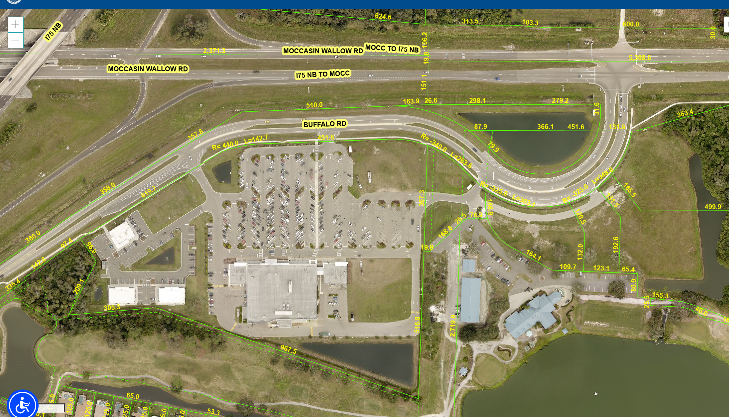
Exhibit B

9690 Buffalo Road (OP 5), Palmetto, FL 34221
Sarasota-Bradenton, FL MSA, Manatee County
Purchase Agreement for 12 FT / 2 Bay 1,900 Prototype
.76 Acres or 110 Ft Frontage and 301 Ft Depth covering 33,110 square feet on the
Moccasin Wallow and Buffalo Roads Fully Signalized Intersection Directly North

