FOR SALE
Office Condominium
The Hanley Building
50 Pine Street, Providence, RI 02903
$125,000.00
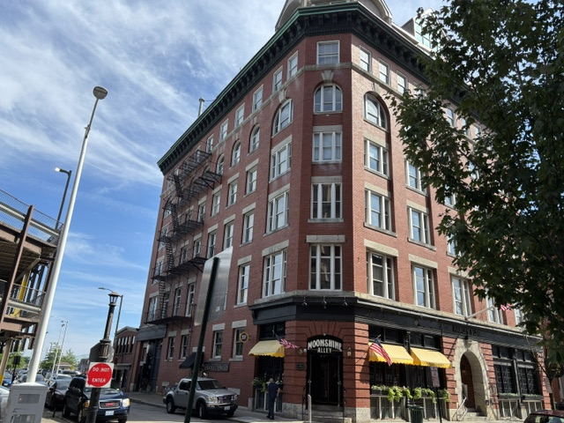

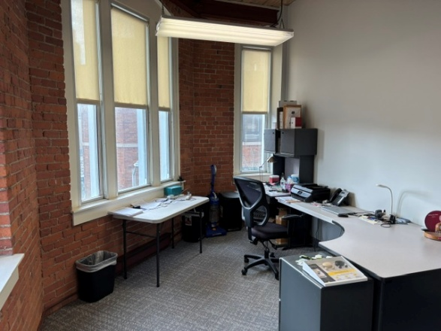  Private Office | 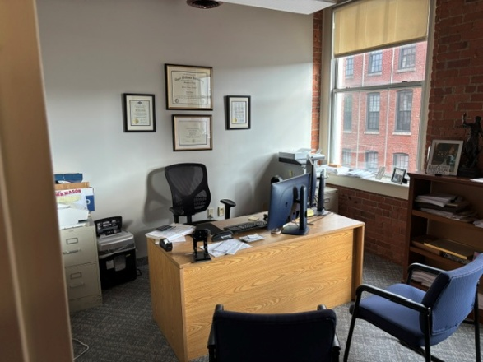  Private Office |  | 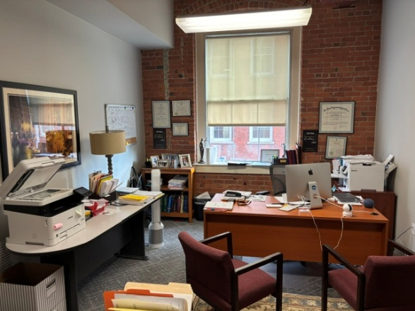  Private Office
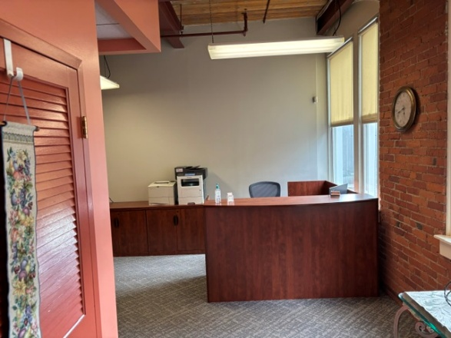  Reception |  | 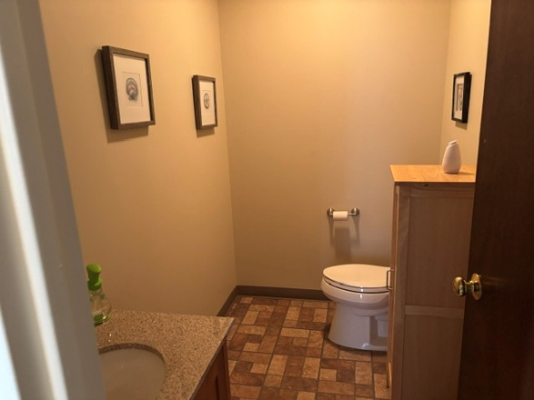  Bath

1,000 Square Feet Mortgage Payment
3 Private Offices Loan Amount: $100,000
1 Reception Area Term: 25 Years
1 Private Bath Rate: 6.5%
Payment: $675/month
Condo Fee: $560/month
RE Taxes: $277/month Total Cost to Occupy
Condo Fee: $560/month
RE Taxes: $277/month
Unit Insurance: $50/month
Janitorial: $85/month
Mortgage: $675/month
Total: $1,647.00/month

For Appointment Contact:

Peter M. Scotti
Peter M. Scotti & Associates
24 Bridge Street, Providence, RI 02903
401-421-8888/401-255/7704 (cell)
pmgbs@scottire.net

