Ground Floor Commercial Unit
To Let
21 Thornleigh Gardens, Bangor, BT20 4NW
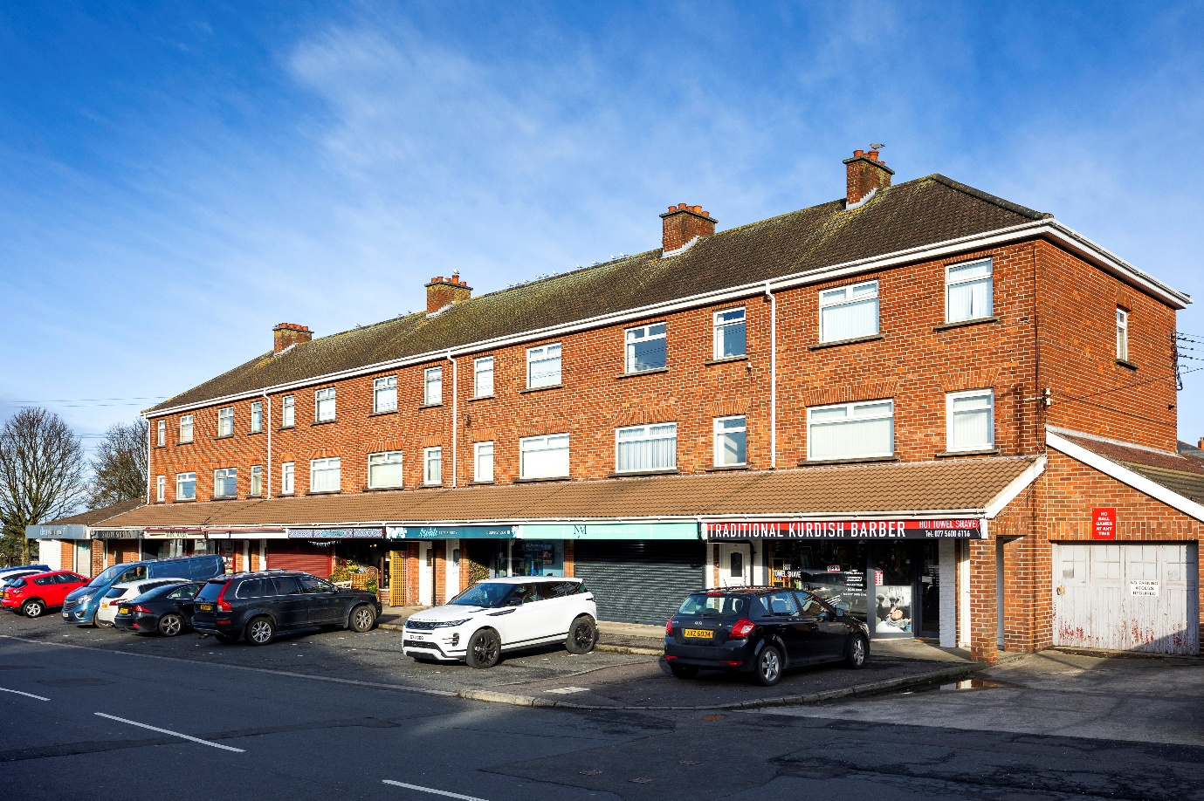
Key Features:
- Excellent commercial premises situated within an extremely popular residential area
- Located just off the Donaghadee Road approximately c. 1 mile from Bangor Town centre.
- The premises extends to approximately c.597 sq. ft.
- Suitable for a variety of commercial uses subject to any required statutory planning consent
- Available 1st September 2026

LOCATION
The subject property is situated just off the B21 Donaghadee Road fronting onto Thornleigh Gardens, an extremely popular residential area located approximately c. 1 mile from Bangor Town centre.

DESCRIPTION
On-site parking is located directly at the front of the property.
The property would be suitable for a variety of uses subject to any required statutory consents.

ACCOMODATION
We calculate the approximate internal area to be approximately 597 sq. ft.

LEASE
Length of lease by negotiation

RATES
NAV: £3,650
Non-Domestic Rate in £ (26-27): 0.60946
Rates Payable: £2,225 per annum

Please note, this property should be eligible for a 20% reduction in rates payable due to Small Business Rates Relief.
We recommend that you contact Land & Property Services to verify these figures (Tel: 0300 200 7801).

RENT
Inviting offers in the region of £7,500 per annum.

SERVICE CHARGE
Tenant to be responsible for the payment of a Service Charge in connection with the upkeep, maintenance, repair and decoration of the building and grounds of which the subject premises form’s part and agent management fees.

VAT
All figures quoted are exclusive of VAT, which we may be payable.

Rent
Inviting offers in the region of £7,500

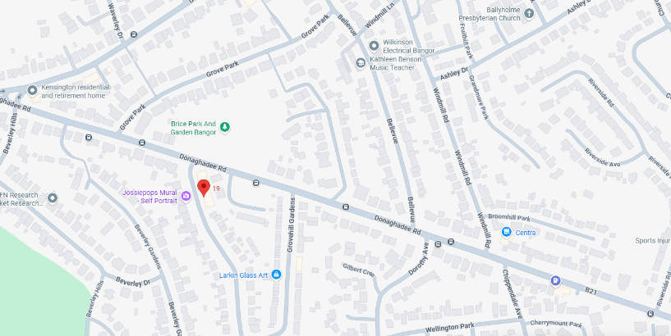

For further information please contact:
Brian Kidd
07885 739063
bkidd@frazerkidd.co.uk
Beth Brady
0775924283
bbrady@frazerkidd.co.uk
Telfair House, 87/89 Victoria Street, Belfast, BT1 4PB
028 9023 3111
mail@frazerkidd.co.uk
frazerkidd.co.uk

Disclaimer
Frazer Kidd Property Limited for themselves and for the vendors of this property whose agents they are, give notice that (I) The particulars are set out as a general outline for the guidance of intending purchasers or lessees, and do not constitute part of an offer or contract; (ii) All descriptions, dimensions, references to condition and necessary permissions for use and occupation, and other details are given in good faith and are believed to be correct, but any intending purchasers or tenants should not rely on them as statements or representations of fact but must satisfy themselves by inspection or otherwise as to the correctness of each of them; (Iii) No person in employment of Frazer Kidd Property Limited has any authority to make or give representations or warranty whatever in relation to this property.
As a business carrying out estate agency work when we enter into a relationship with a customer, we are required, if applicable, to verify the identity of both vendor and purchaser as outlined in the Money Laundering, Terrorist Financing and Transfer of Funds (information on the payer) Regulations 2017 – http://www.legislation.gov.uk/uksi/2017/692/made. In accordance with legislation, any information and documentation provided by you will be held for a period of five years from when you cease to have a contractual relationship with Frazer Kidd Property Limited. The information will be held in accordance with the General Data Protection Regulations (GDPR) and will not be passed on to any other party unless we are required to do so by law.

