279-287 High Street, Hounslow , TW3 1EF (Hounslow Real Estates Ltd)
Abdul: 07449779351
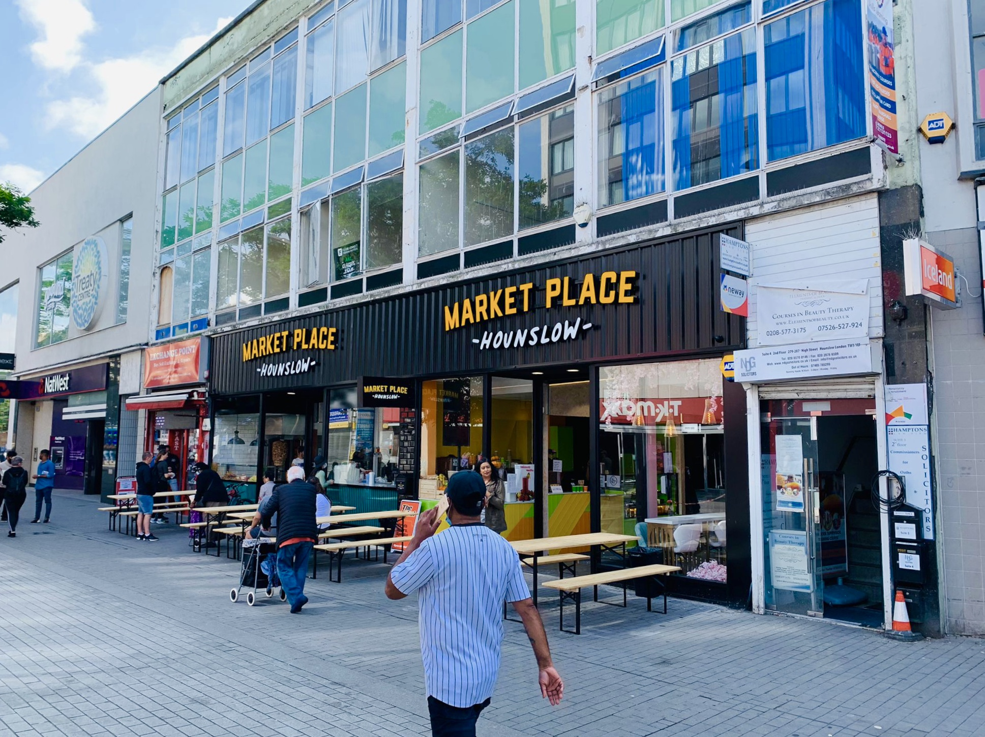
Available Space | Approx size (sq ft) | Desk Recommendation | Price Per Month ex VAT
Suite 3 (1st Floor) | 1,000 | 15+ | £2,100

Description: Building is located in the commercial heart of Hounslow on Hounslow high street

Transport: The closest transport links are Hounslow Central and hounslow East Tube stations (Piccadilly Line and Cross Rail) and the Bell bus stop

What does the above price include?
- Rent
- Service & Maintenance Charges
- Communal cleaning

Additional Costs

- Business Rates

Building Features
- 24/7 Main Reception
- 24/7 Access to the building
- Heating
- Fully carpets
- Unfurnished

