499 Bedford #101

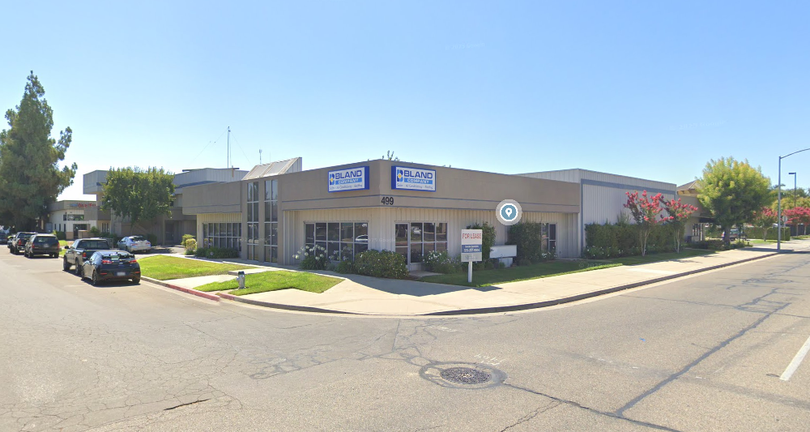
499 W Bedford Ave #101  Fresno, CA 93711  - 3,250 sqft Industrial building  - $1.35 per sq ft plus $0.15 NNN  - Reception Area, Private offices, warehouse with one large roll up door. North of Herndon off Ingram.  Great Location & Great work area! | SJ Valley Properties  Shawn Sanders  559-287-9004  499 West Bedford Ave. #102

BRE# 02014259

FOR LEASE!

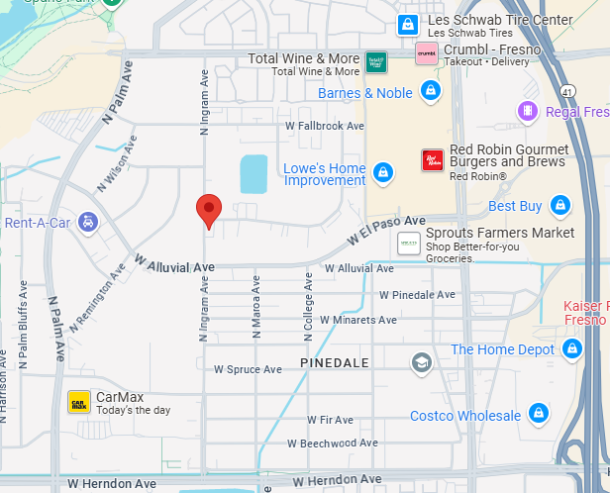
\
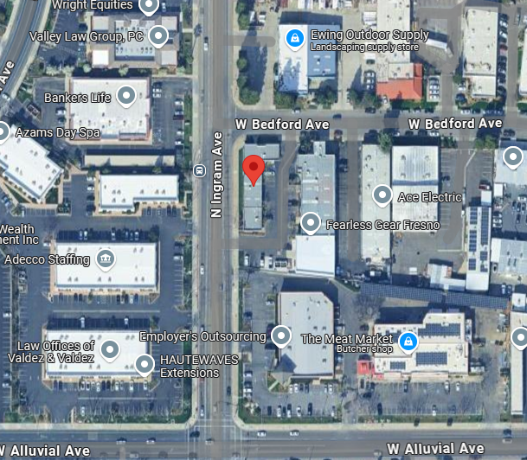
BRE# 02014259

