Retail space for rent
Address: 1111 W. Pacific Coast Highway, Harbor City 90710
Unit: #7
Location: Across south bay Kaiser medical center
Business: Acupuncture/vacant
Details: 6 individal rooms and reception area, bath room
Size: 1,215Sq.Ft
Rent: base rent $2,50/Sq.Ft plus CAM, current 0.65/Sq.Ft
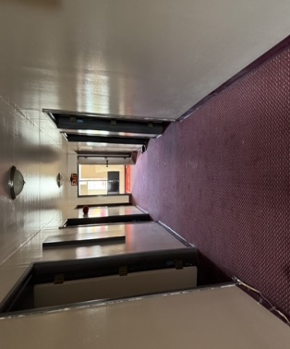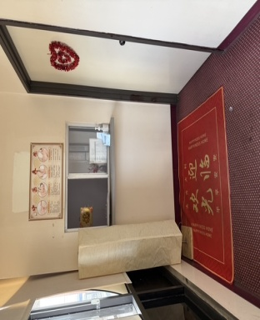

Address: 1111 W. Pacific Coast Highway, #11, Harbor City 90710
Unit: #11
Size: 1,100Sq.Ft
Rent: $2.50/Sq.Ft plus CAM 0.65/Sq.Ft
Business: Flower shop/vacant


