
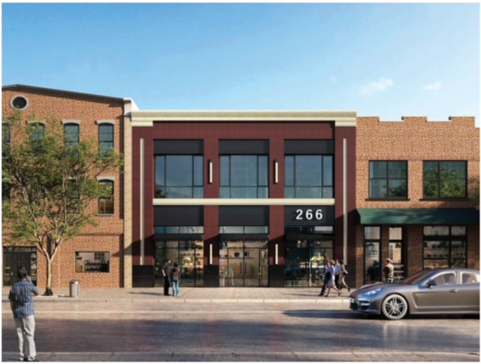

266 Jericho Turnpike

Floral Park NY
For Lease
NEW CONSTRUCTION ...TO BE COMPLETED 4 QUARTER OF 2024..
SMALL OFFICE SUITES FROM 165 SQUARE FEET TO 600 SQUARE FEET .. AND 2340 SQUARE FEET OF RETAIL ON THE FIRST FLOOR
SEE ATTACHMENT FOR FLOOR AND PRICING
For further information or to arrange inspection, please contact:

Frank Posillico
Franic Realty
Managing Principal
516-852-9087
fposillico@franic.com

