
To Let
For further information please contact:
01908 611408
73 High Street, Newport Pagnell, Milton Keynes, MK16 8AB

Unit 6 53/54 Triangle Building,
Milton Keynes, MK12 5FJ
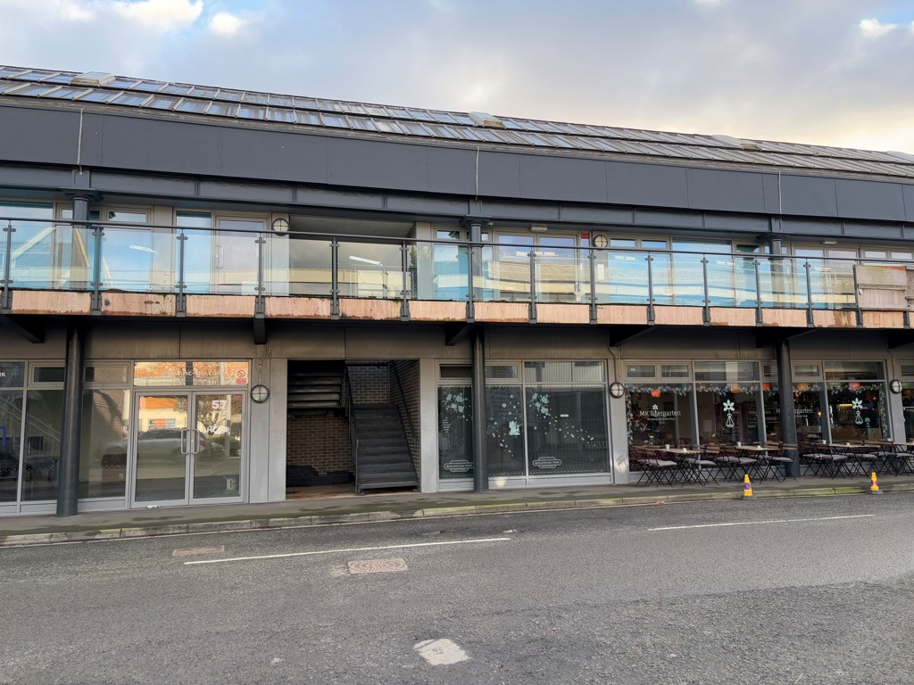


£70,000 Per Annum
Substantial first-floor office space making it ideal for a variety of business activities. Designed to accommodate dynamic and large-scale operations, the unit includes a welcoming Reception Area, a versatile Open Plan Office space suitable for approximately 60 desks, and 6 glass-fronted ancillary offices perfect for private meetings or collaborative work. Additional amenities include a locker room, ladies', gents', and disabled toilets, a staff room with a kitchenette, and a secondary kitchen area.
The property is equipped with essential climate control features, including electric heating and air conditioning, ensuring a comfortable working environment year-round. Ample parking spaces further enhance the convenience of this site.

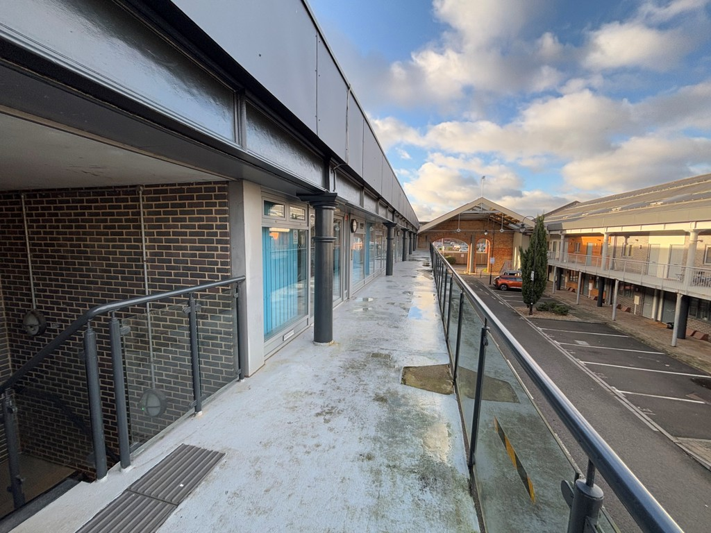
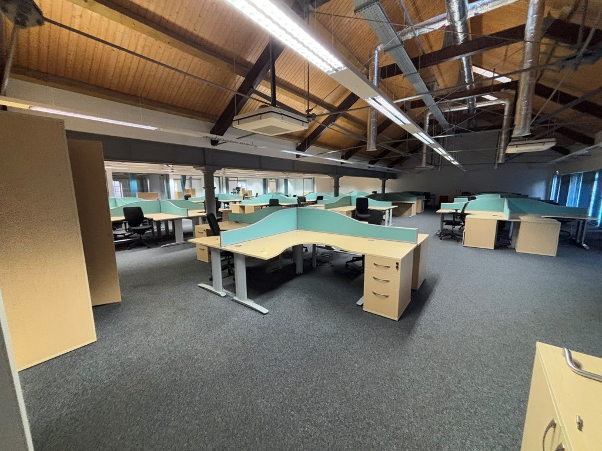
7,158 Sq Ft / 664.98 Sq M
01908 611408
73 High Street, Newport Pagnell, Milton Keynes, MK16 8AB
Unit 6 53/54 Triangle Building, Milton Keynes, MK12 5FJ
For further information please contact:

Location

EPC
Situated in the thriving district of Wolverton, Milton Keynes, the property boasts a strategic location with excellent connectivity. Convenient road links to the A6 and M1 make it easily accessible for employees and clients alike. For those traveling by rail, Wolverton train station is within close proximity, offering fast and direct services to Central London and connections to other major cities.

Wolverton itself is a vibrant area with a rich industrial heritage, blending modern amenities with a welcoming community atmosphere. A variety of local businesses, eateries, and services add to the area's appeal, making this property an ideal choice for any company looking to establish or expand its presence in the Milton Keynes region.
Strictly by appointment only please contact:

Stimpsons Eves is the trading name of Stimpsons Eves Limited Registered in England & Wales. Company Reg. no; 6512125 whose registered address is 138 Bromham Road, Bedford, MK40 2QW. Note: Messrs. Stimpsons Eves for themselves and for vendors or lessons of this property whose agents they are given notice that: (i) the particulars are set out as a general outline only for the guidance of intended purchases or lessees, and do not constitute, nor constitute part of, an offer or contract;(ii) all descriptions, dimensions, reference to condition and necessary permissions for use and occupation, and other details are given without responsibility and any intending purchases or tenants should not rely on them as statements or representations of fact but must satisfy themselves by inspection or otherwise as to the correctness of each of them; (iii) no person in the employment of Messrs. Stimpsons Eves has any authority to make or give any representation or warranty whatever in relation to this property.
Viewing
Each party is to be responsible for their own legal costs.
Costs
The EPC rating for the property is 39 - Band B.
VAT
All figures are quoted exclusive of VAT, purchasers and lessees must satisfy themselves as to the applicable VAT position, seeking appropriate professional advice.
Terms & Tenure
The premises are available to let on new terms to be agreed at a rental of £70,000 per annum exclusive.

Accommodation
First Floor Office 7,158 sq ft (664 sq m)

Rates
Chloe Humphreys chloe.humphreys@stimpsonseves.co.uk
Tel: 01908 611 408 | Mo. 0775 170 9097

Rateable Value TBC. The rates payable may be affected by transitional arrangements. Interested parties should call the local Rating Authority for further advice.

