- WATERWORKS OFFICES & MARINA
1818 WESTLAKE AVENUE NORTH
SEATTLE, WA 98109

SUITE 18-402

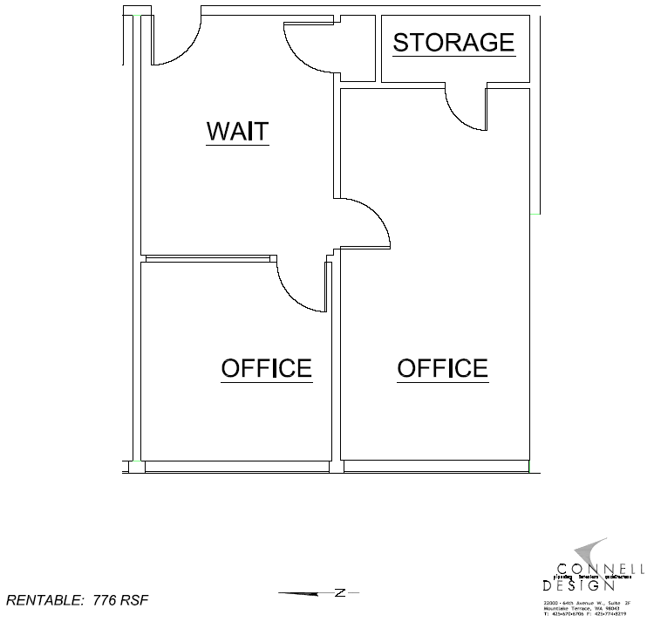

TEMPERATE PARADISE PROPERTIES, LLC
PHONE: 206-851-0036

