LOWER LEVEL


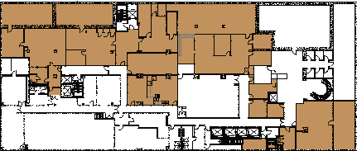
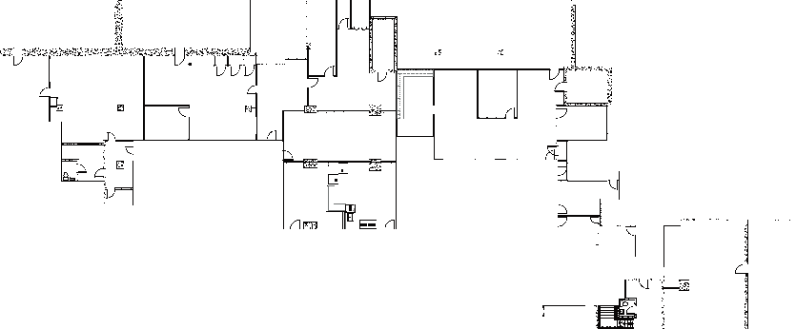
 |  | 736 MARKET ST, CHATTANOOGA, TN 37402

THE SPACE  18,460 RSF  For more information please contact  Gail Battle, Senior Vice President  704-333-3866 / gail@simpsonorg.com | FEATURES  - Walk to dozens of new restaurants nearby  - Garage deck parking  - Lightning fast broadband available  - Innovation District  - Art Alley Behind Building

