EXHIBIT A
11551 FOREST CENTRAL DRIVE
SUITE 103
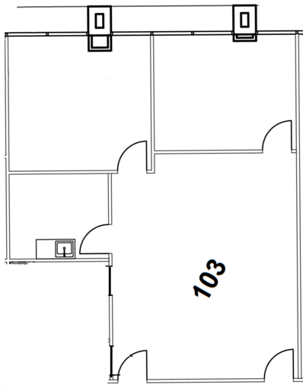

Approximately 1,140 SF

