
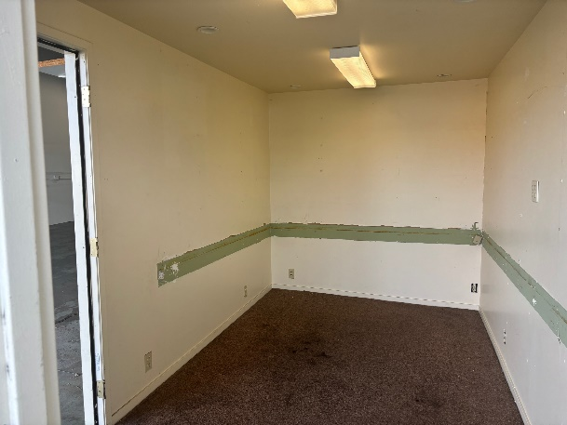
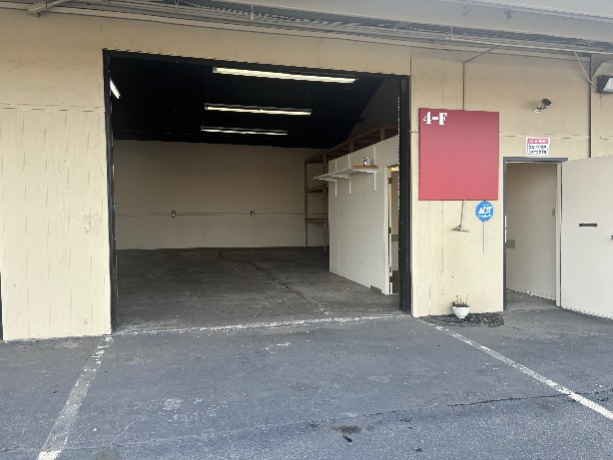
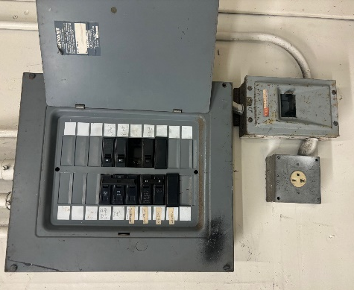

Roll-Up Door Power Side Office
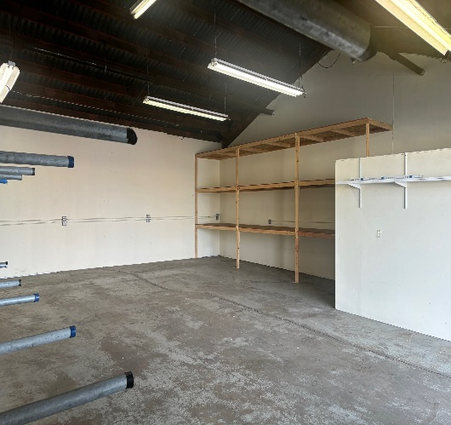
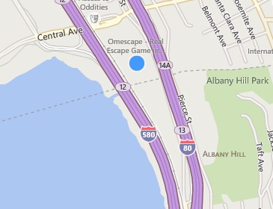
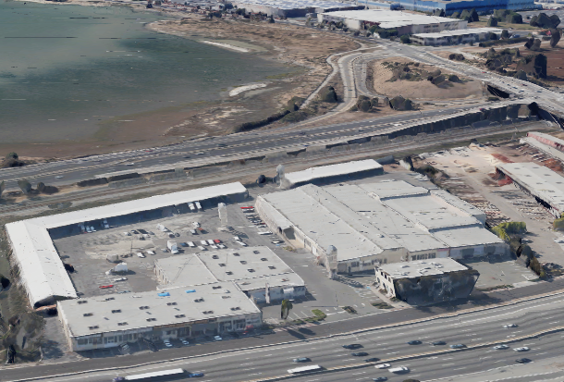
S.F. Bay
Site



Shop Here


Facing 255,000+ Captive Cars/day Racking Storage Convenient Location

I-80 SHOP SPACE FOR LEASE

5327 Jacuzzi Street #4-F: 1,200 Sq. Ft.

Shop or Business Service Suite with roll-up door featuring:

- Duel Access Doors
- Side Office Room (150 Sq. Ft.)
- Off Street Parking
- Direct Freeway Exposure
- Open Space
- Restroom Access

$1.49/Sq. Ft. Monthly Industrial Gross + 42¢ CAMS.

Available NOW!
FOR FURTHER INFORMATION PLEASE CONTACT Todd Kollin 510/325-9714
CITY | Richmond Bayside | LISTING CO. | McNally Realty Advisors
ADDRESS | 5327 Jacuzzi Street #4-F | LISTING AGT. | Todd Kollin
CROSS ST. | Interstate 80 | PHONE # | 510/325-9714
SPACE AVAIL. | 1,200 Sq. Ft. | LIST DATES | 2/25
PRICE | $2,292/ month all-in | DRE # | 982919
PROP. TYPE | Service / Shop / Warehouse | FEE TO S.O. | ½ 6-6-5

Information Herein Deemed Reliable but not Guaranteed.

