- WATERWORKS MARINA & OFFICES
1836 WESTLAKE AVENUE NORTH
SEATTLE, WA 98109

SUITE 36-101

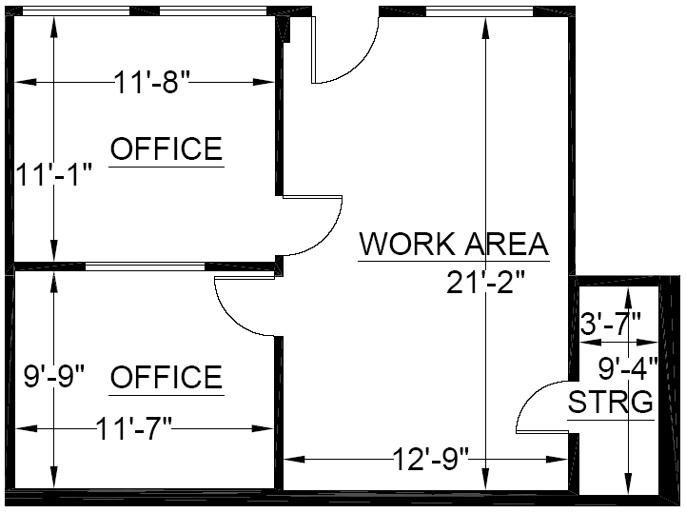

Rentable: 645 rsq. ft.
(As measured March 2002)
TEMPERATE PARADISE PROPERTIES LLC

