

145 New Street Suite A
Decatur, Ga 30030
400 sq. ft.
Unit Details
Approx 400 sq ft. warehouse space
No water or HVAC Strictly Storage
End unit
Conveniently located 1 mile from Downtown Decatur/Decatur Square
One block from Avondale Marta Train Station
$600Rent/mo/NNN Cam, Tax, Insurance $200 Electric responsibility Tenant

Total Monthly rental Amount $800

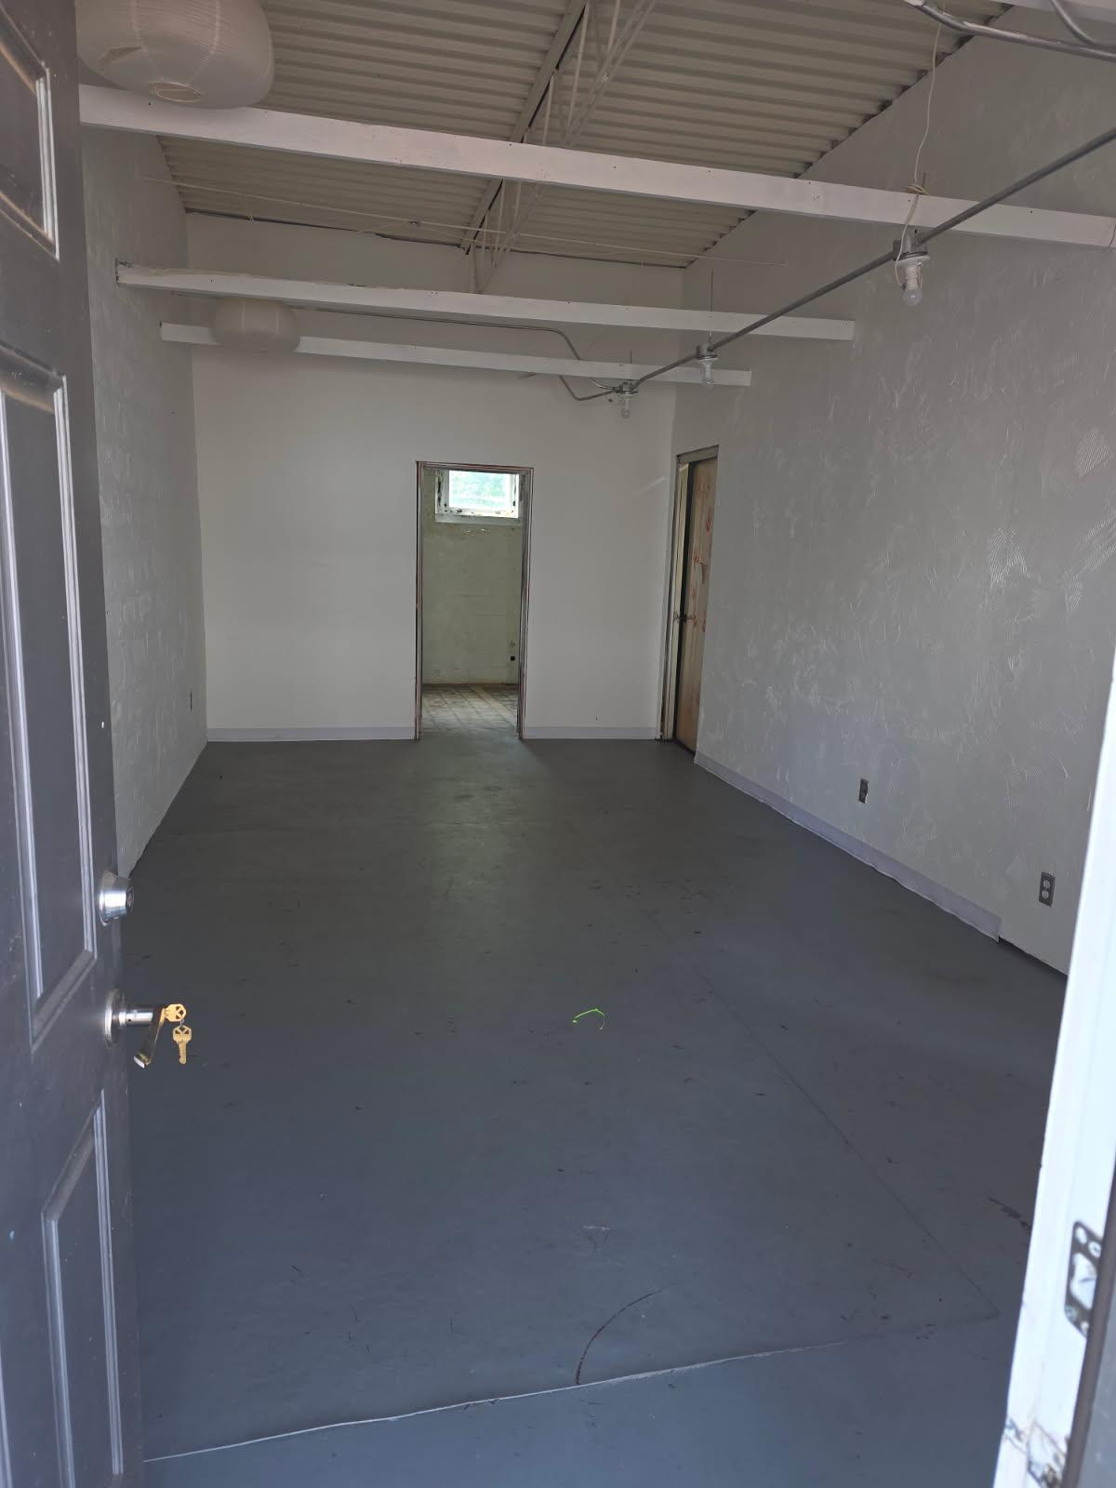

Leasing requirements:
- Personal guarantee required
- Personal credit score of 675 or more required
- First month’s rent and security deposit due at lease signing
- RENT + CAM + UTIL+ TI + HVAC replacement fee= monthly payment

Broker Commission:
*Brokers to be paid ½ of first month’s rent with 5% residual.
**Brokers must make first contact with EDS Leasing office for commission to paid on executed leases by EDS. If EDS shows the tenant the property first, tenant will be responsible for Broker’s Commission.

