- WATERWORKS OFFICES & MARINA
1818 WESTLAKE AVENUE NORTH
SEATTLE, WA 98109

SUITE 18-124

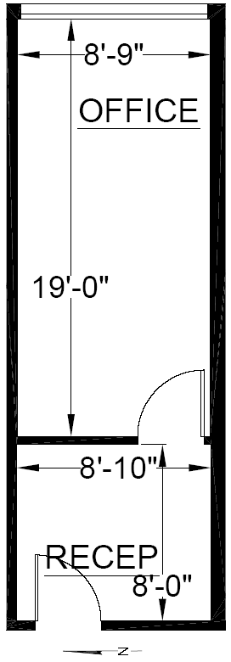

RENTABLE: 316 sq. ft.
(As measured March 2002)

TEMPERATE PARADISE PROPERTIES, LLC
206-930-1289

