Ralph Bernascone
Jennisons
Nep Town Road
Henfield, West Sussex BN5 9DY

Tel: 07717 576337
Email: salesandlettings@whiteover.co.uk

BBH15
WAREHOUSE/FACTORY UNITS

7,510 SQ.FT TO 16,915 SQ.FT. APPROX.

23, 24 & 25 LAWSON HUNT INDUSTRIAL PARK,

BROADBRIDGE HEATH, WEST SUSSEX RH12 3JR

TO LET ON NEW LEASE(S)

Location: The premises are located on the A281 Horsham to Guildford
Road approx 2 miles west of Horsham town centre and 1 mile
from the A24 London to Worthing Road.

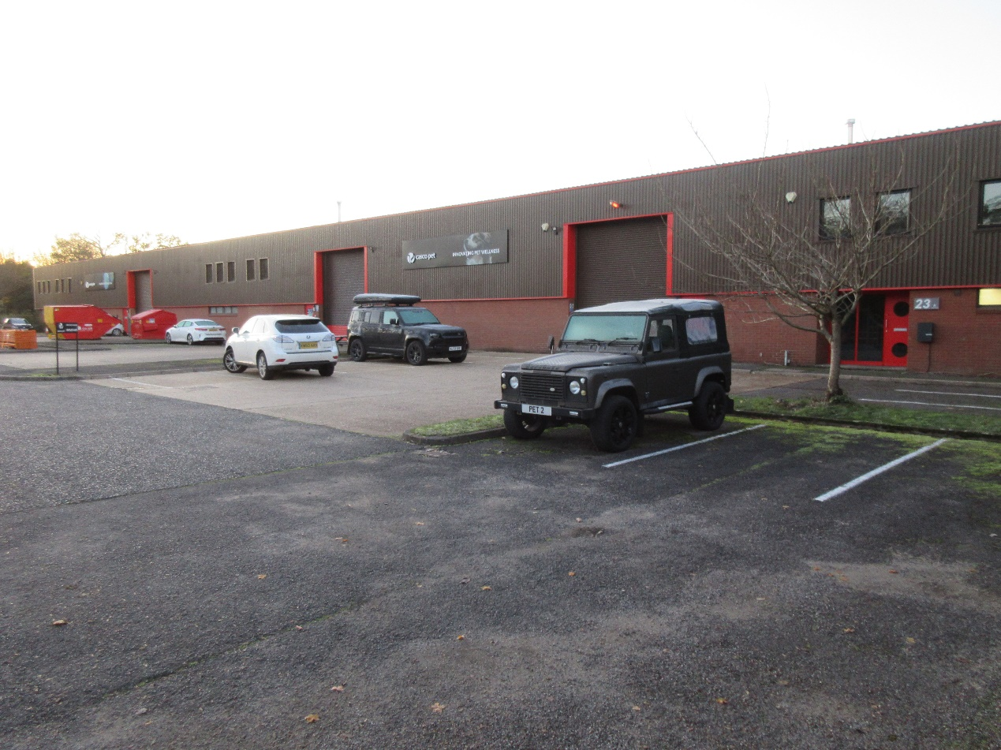

Description: Steel portal frame construction with part brick and part steel
Profile cladding to the walls and insulated roof.

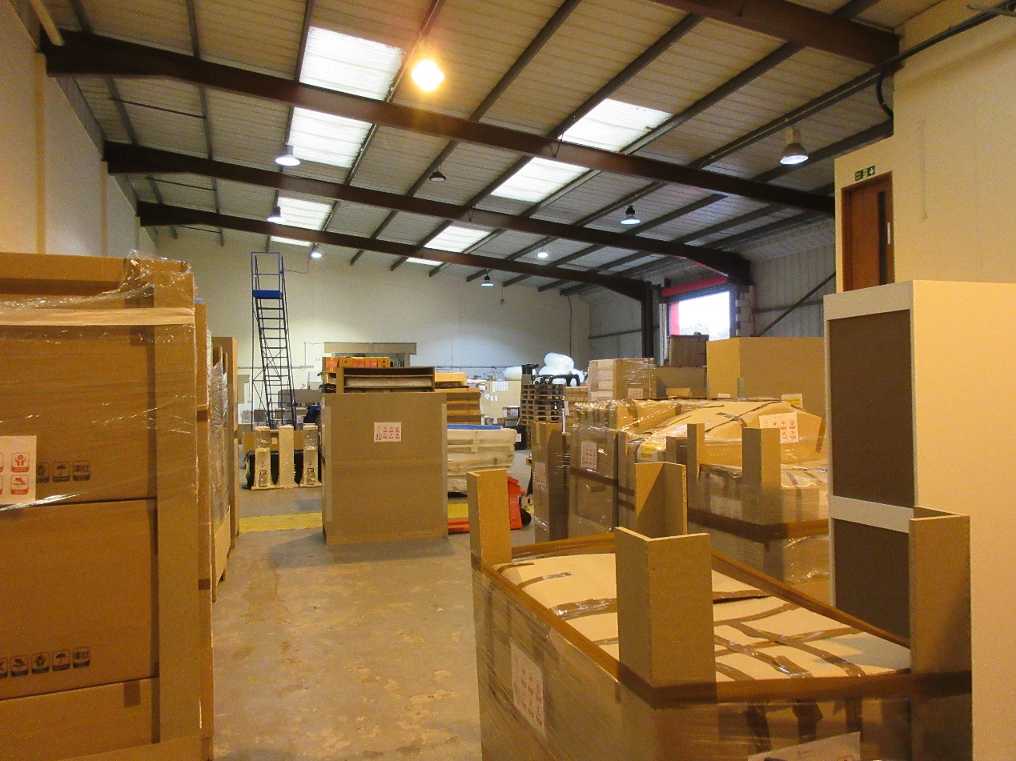

Amenities:
- 24 hour manned security
- Very generous car parking spaces
- 2 electric loading doors to unit 23/24
- One electric loading door to unit 25
- 3 phase power
- Lighting
- Excellent headroom

Floor Areas: Units 23/24

Ground floor warehouse/factory 8,896 sq.ft
First Floor Offices. 509 sq.ft
Total 9,405 sq.ft

Unit 25
Ground floor warehouse/factory. 6,701 sq.ft
First floor offices. 809 sq.ft
Total. 7,510 sq.ft

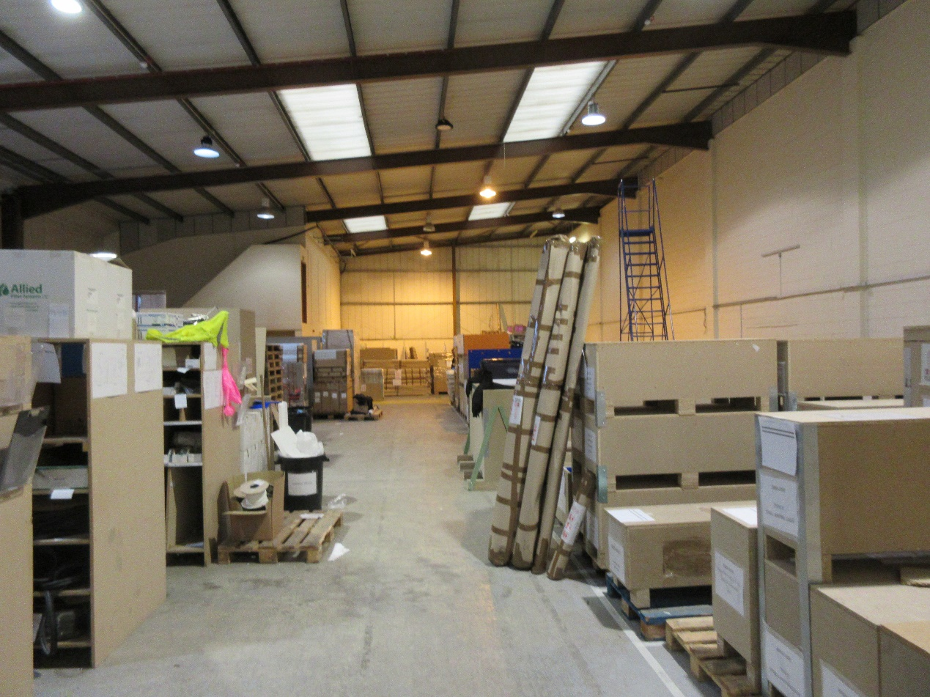

EPC: Unit 23/24 – 66c – valid until March 2032
Unit 25 – 71c – valid until February 2029

Rateable Value: Rateable values for Unit 23/24 £80,500
Rateable value for Unit 25 £64,000

Lease(s): A new full repairing and insuring lease for a term of 10 years
with an upward only rent review at the end of the fifth year,
the lease(s) to be outside of Provisions of the Landlord &
Tenant Act 1954.

Rents: Unit 23/24 - £75,240 (seventy five thousand, two hundred
and forty pounds per annum exclusive + VAT.
Unit 25 - £60,080 (sixty thousand and eighty pounds) per
annum exclusive + VAT.

Estate
Management
Charge: For the 24 hour manned security and the upkeep of the estate
roads and general upkeep, there is a service charge levied,
currently at approx £1.85 per square foot + VAT.

Legal Costs: Each party to be responsible for their own legal costs.

Viewing: Through Ralph Bernascone 07717576337.
Subject to Contract

