3 Gold Mine Road
Flanders

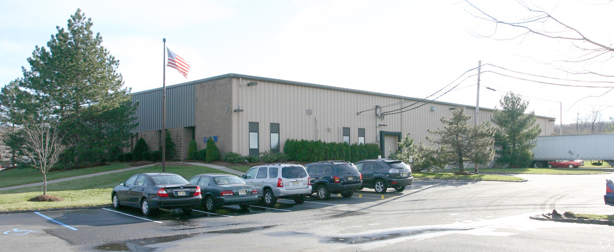

Size: 2,800 Square Feet

Office: One Small – Two bathrooms

Ceilings: 20’ Clear Height

Loading: 1 Tailgate & 12’ x 14’ Drive-in

Lease Price: $4,550/month Full Gross
Includes Electric

Fully Air Conditioned
½ Mile to Exit 27 of Route 80 on Route 206

All information is from a source deemed to be reliable, however, No warranty or representation, express or implied, is made to the accuracy of the information contained herein, and same is submitted subject to errors, omission, change of price, rental or other conditions, withdrawal without notice, and to any special conditions imposed by our principals and clients.

