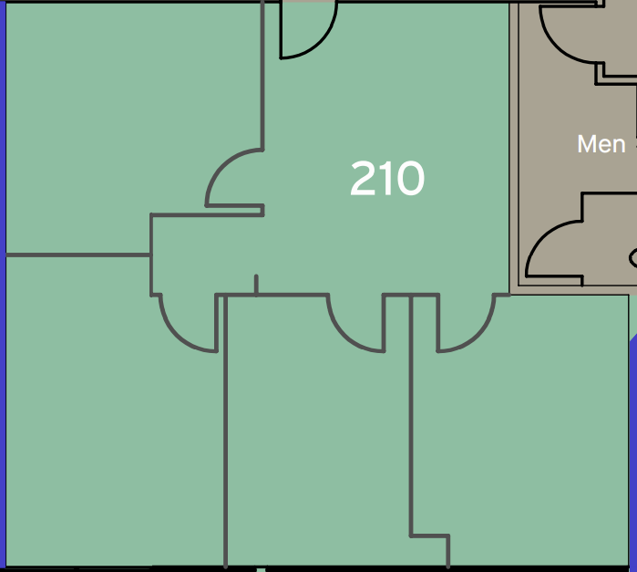

Cedarbrook Business Park
12862-210 1,133 SF
(714) 638-0288

