 The Green Pit, LLC
10 NE Cascade Ave. East Wenatchee, Wa. 98802 Baker Flats Industrial Park
Industrial Space Lease Opportunity
Presented by Bret Pittsinger 509-668-2751 bret@vandorensales.com
Property Overview
Total Space: 3393 sq ft ideal for storage
Ceiling Height: 10-14’
Construction: metal fab.
Climate Control: None. Need to insulate if required. Power available.
Availability: February 1st, 2026
Lease Terms: Estimated $.85/sq ft for 2-5-year lease
Features & Amenities
Common Storage: 3393 sq ft available
Parking: Dedicated spaces
Access:
- Loading dock
- Overhead door 2 x 10’ x 14’
- Man-door entrance
- Common locked gate

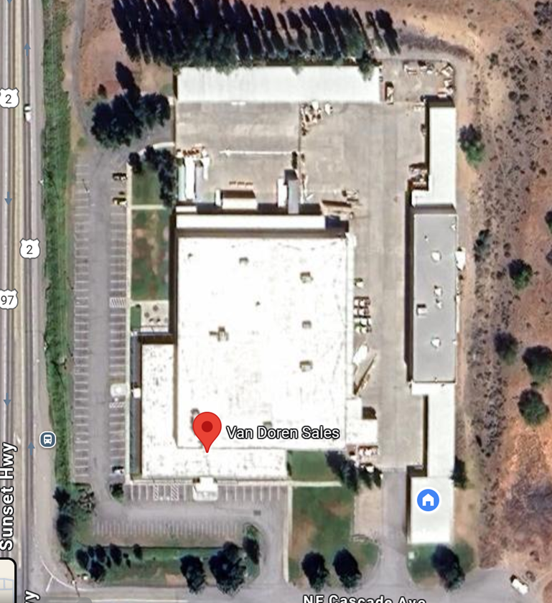P
Proposed Space

Highway 97----------------------------------------------------------------------------------------------------

Space available immediately



