SHOP UNIT

TO LET

9 Old Bridge Street

Ayr, KA7 1QA

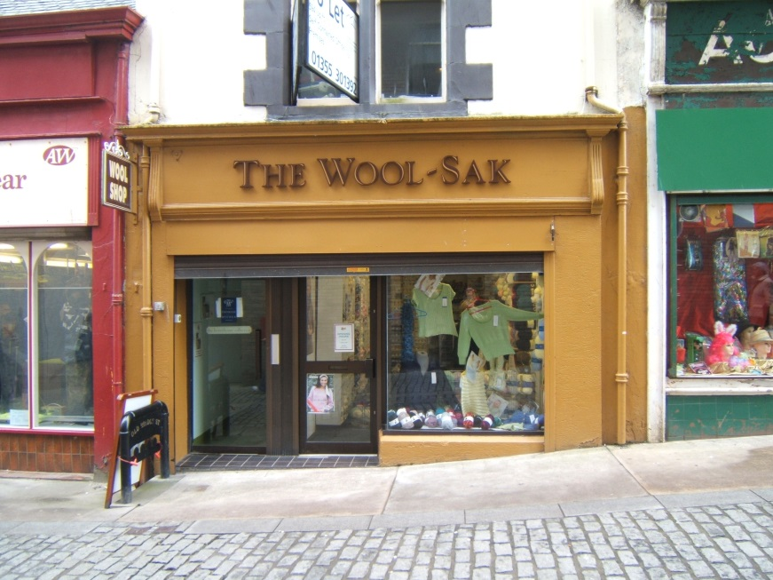

LOCATION

The property is located on Old Bridge Street which is accessed from the High St, Ayr’s principal shopping street. The shop can also be accessed from River Street via a pedestrian bridge.

SITUATION

The High Street is occupied by the majority of national retailers including Marks and Spencer, Debenhams, Boots etc. The surrounding occupiers are predominantly local retailers.

DESCRIPTION

The premises comprise a single windowed retail unit arranged over the ground floor of a traditional stone built building under a pitched and slated roof. The upper premises are residential.

ACCOMMODATION

We have been advised that the property has a net internal floor areas of 320 sq.ft (30 sq.m.)

The premises benefit from an internal toilet and roller shutters to the shopfront.

RATEABLE VALUE

We have been informed by South Ayrshire Council that the property has been entered in the current valuation roll for 2017 as follows:-

RV

9 Old Bridge Street, Ayr £4,000

LEASE TERMS

Our clients are seeking rental offers of £6,000 p.a. These premises have not been elected for VAT therefore no VAT will be chargeable.

Our clients are seeking a 10 year lease subject to 5 yearly rent reviews.

The tenant will be responsible for payment of rates and the proportion of the common charges together with legal costs in connection with the lease.

ENERGY PERFORMANCE CERTIFICATE

We have been advised that the property has an EPC Rating of G. A copy of the EPC and recommendation report can be provided upon request

VIEWING

Viewing arrangements by appointment with the sole letting agent:-

G2 Property Consultants,
South Craighall Lodge,
Jackton Road,
Jackton,
GLASGOW,
G75 8RR.

Tel: 01355 301392

E-mail: info@g2property.com

Property Misdescriptions Act 1991

1. The information contained within these particulars has been checked and, unless otherwise stated, is understood to be materially correct at the date of publication. After these details have been printed circumstances may change outwith our control. When we are advised of any changes we will endeavour to inform all enquirers at the earliest opportunity.

2. Date of publication: 24/1/2021

3. Unless otherwise stated, all prices and rents are quoted exclusive of Value Added Tax. Prospective purchasers/lessees must satisfy themselves independently as to the incidence of VAT in respect of any transaction.

4. These particulars are not warranted and should not be taken to form part of any contract.

