PROPERTY SPECIFICATIONS: 3400 CARLINS PARK DRIVE, BALTIMORE, MD 21215

Building Size Total: 10,100 square feet

Available: 10,100 square feet

Lot Size: 2.1 acres +/- mostly fenced and paved

Construction: Block and Metal

Year Built: 1992

Office Area: 1,500–1,800 square feet +/-

Loading: 3 docks (8’x10’ / 9’ x 10’) and 14 drive-in doors (10’ x 12’)

Ceiling Height: 11.5’ at the eaves up to 16.5’ in the center

Electric: 3 phase, 120/208v, 200 amps (estimated)

Zoning: I-1

Sprinkler: None

Roof: Metal – standing seam

Heat: Gas, infra-red

Column Spacing: Clear span

Lighting: Fluorescent

Base Rate: $10.00 psf, nn

Sale: Negotiable

RE Taxes: Approximately $7,500 (2024-25 tax year) / Insurance: $4,200

Contact: Jim Caronna, SIOR
jcaronna@klnb.com

Remarks: Free standing, fully fenced and paved warehouse 2.3 miles from I-83. Enterprise/Hub Zone status. Exterior building lighting.

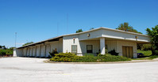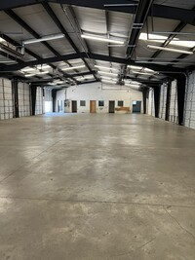

ALL INFORMATION OBTAINED FROM RELIABLE SOURCES, BUT NO WARRANTY IS MADE AS TO ITS ACCURACY

