
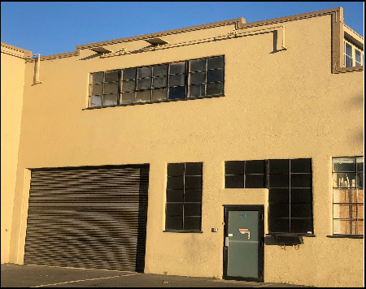
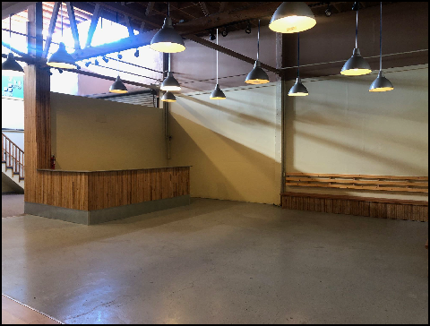
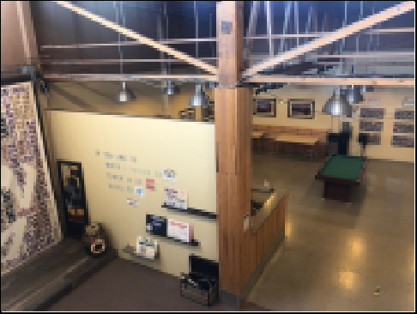
Grade Level Roll-Up Door Wide Open Space w/Tall Ceiling View from Loft
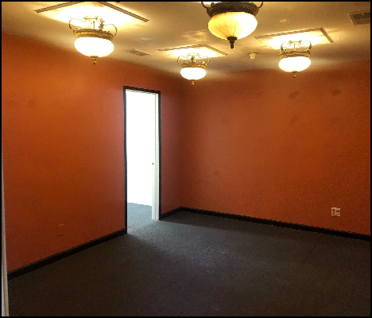
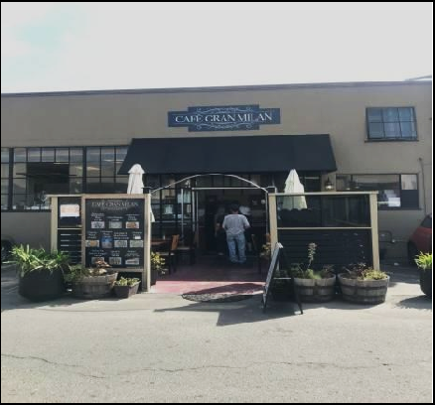
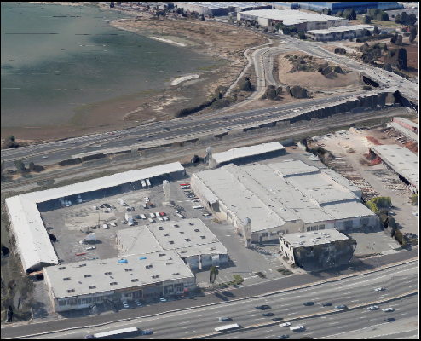


Spacious Office On-Site Deli & Pizza Upwards of 255,000+ Captive Cars/day

LOFT PLAN ENTERTAINMENT, or CREATIVE SPACE FOR LEASE

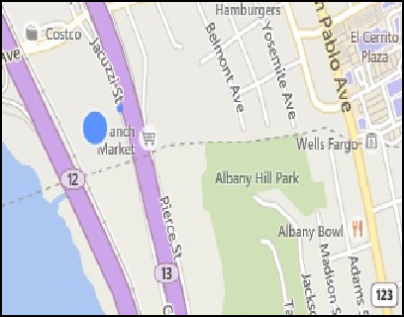
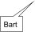

5327 Jacuzzi Street #3-H: ±3,614 Sq. Ft.
Open Plan Creative Space featuring:
- Eight+ Private Offices - Delicious On-Site Cafe
- Gas Space Heaters - Open Space w/ Skylights
- Off Street Parking - Restrooms Adjacent to Space
- Extra Offices can be removed - Club or assembly uses ok
Available NOW! A few blocks from BART!
Please See Floor Plan on Back.
$1.20/Sq. Ft. Monthly Net + 42¢ CAMS.
FOR FURTHER INFORMATION PLEASE CONTACT Peter McNally 510/848-6007
CITY | Richmond Bayside | LISTING CO. | McNally Realty Advisors
ADDRESS | 5327 Jacuzzi Street#3-H | LISTING AGT. | Peter McNally
CROSS ST. | Interstate 80/Central Ave. | PHONE # | 510/848-6007
SPACE AVAIL. | 3,614 Sq. Ft. | LIST DATES | 5/26
PRICE | $5,855 / month all- in | DRE # | 982919
PROP. TYPE | Office/R&D/Lt.Ind | FEE TO S.O. | ½ of 6-6-5-4-4%
Information Herein Deemed Reliable but not Guaranteed.



