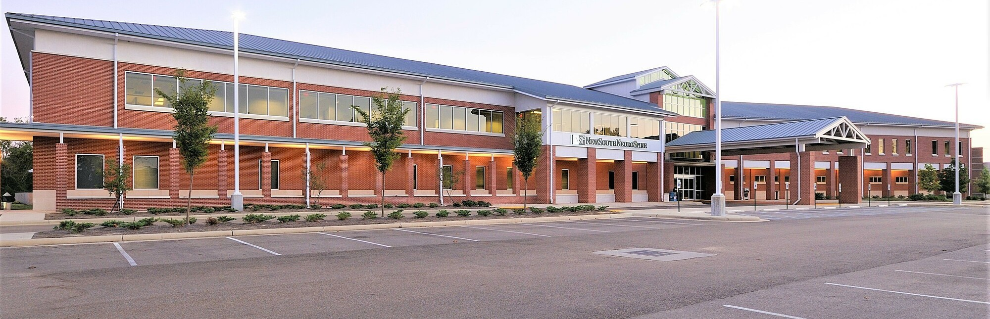

MEDICAL OFFICE BUILDING FOR LEASE
Brokered By Duckworth Realty, Inc. dba Concord Companies | 601.914.0800 | https:concordcompanies.co

NEWSOUTH NEUROSPINE

2470 Flowood Dr, Flowood, MS 39232

JOHN MICHAEL HOLTMANN
Principal 601.914.0800
johnmichael@concordcompanies.co

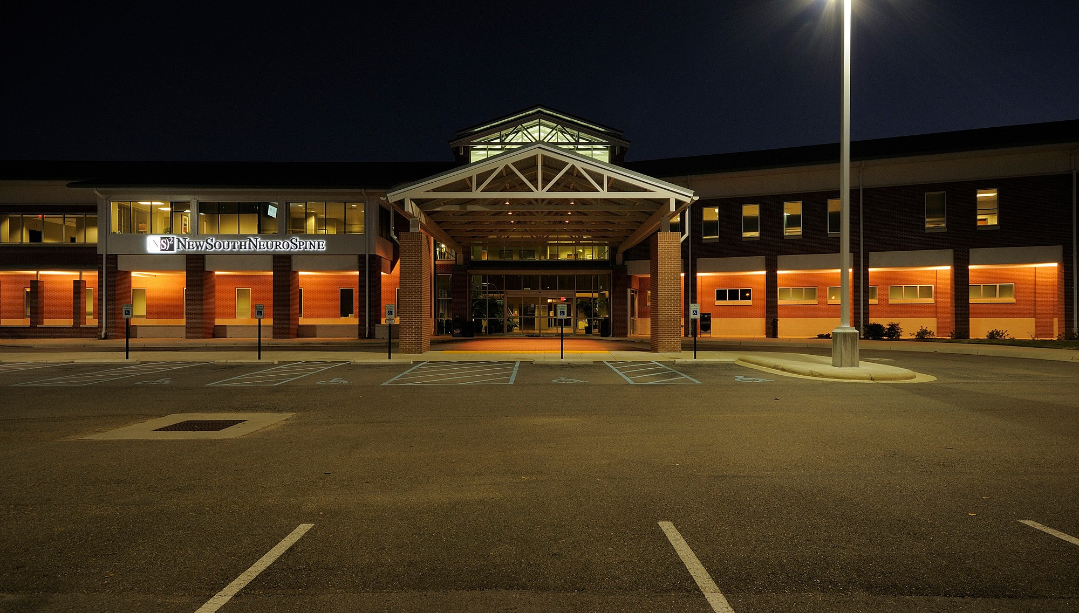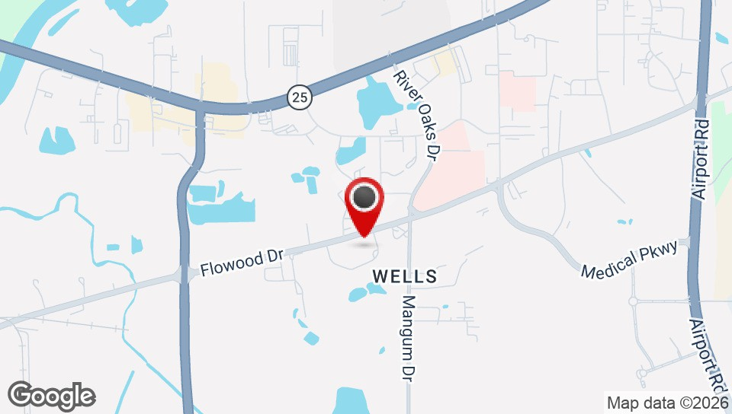

OFFERING SUMMARY

Lease Rate: Negotiable

Building Size: 57,272 SF

Available SF: 10,000 - 14,000 SF
Number of Units: 3
Year Built: 2008
Zoning: C-3

PROPERTY OVERVIEW
Concord Companies is happy to list for lease, this premier medical office suite located within the NewSouth NeuroSpine Medical Office Facility in Flowood, MS. The unbeatable location lies in close proximity to River Oaks Hospital, Merit Health Women's Hospital, and Lakeland Drive (Hwy 25), providing direct access to additional hospitals such as UMMC, St. Dominic, and Baptist. The brand new West Rankin Parkway, less than a mile from the site, further ties the location into Pearl, Brandon, and Richland. An abundance of dining and retail options and several private schools are also nearby. The available space lies on the western wing of the 2nd floor (elevator & stair access) and can accommodate between 10-14,000sf users. The current layout is medical office intensive, and an additional lecture/war room can be leased or used on a case by case basis. Give us a call today! (601)-914-0800

HIGHLIGHTS
- Class A Medical Office Space
- 10-14,000sf available
- Positioned at the core of the Medical corridor in Flowood
- Close proximity to numerous hospitals
- Easy Access to Lakeland Drive (Highway 25)

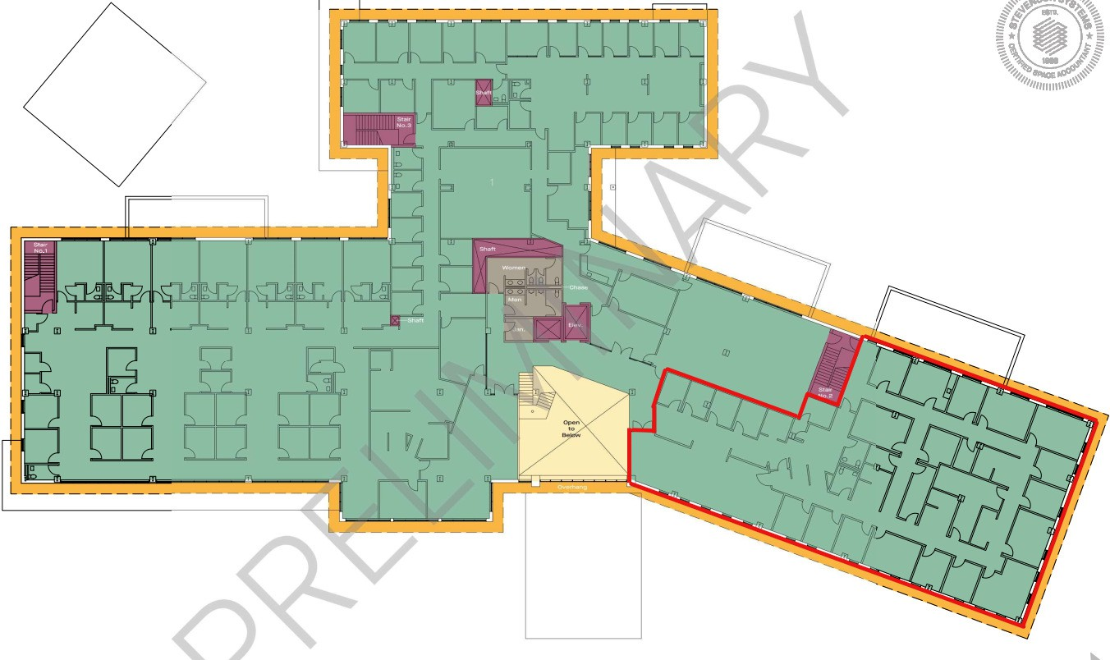
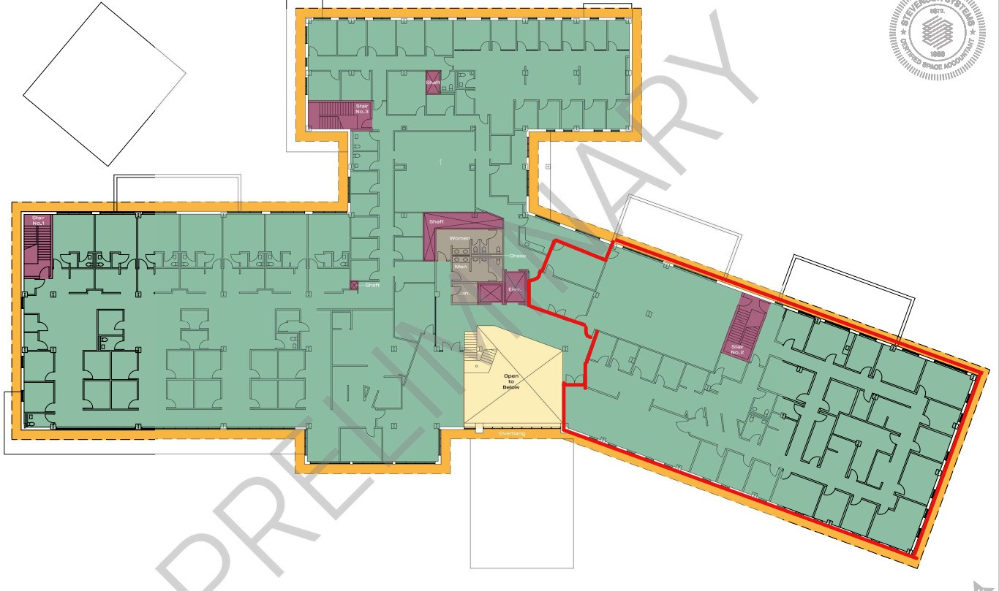

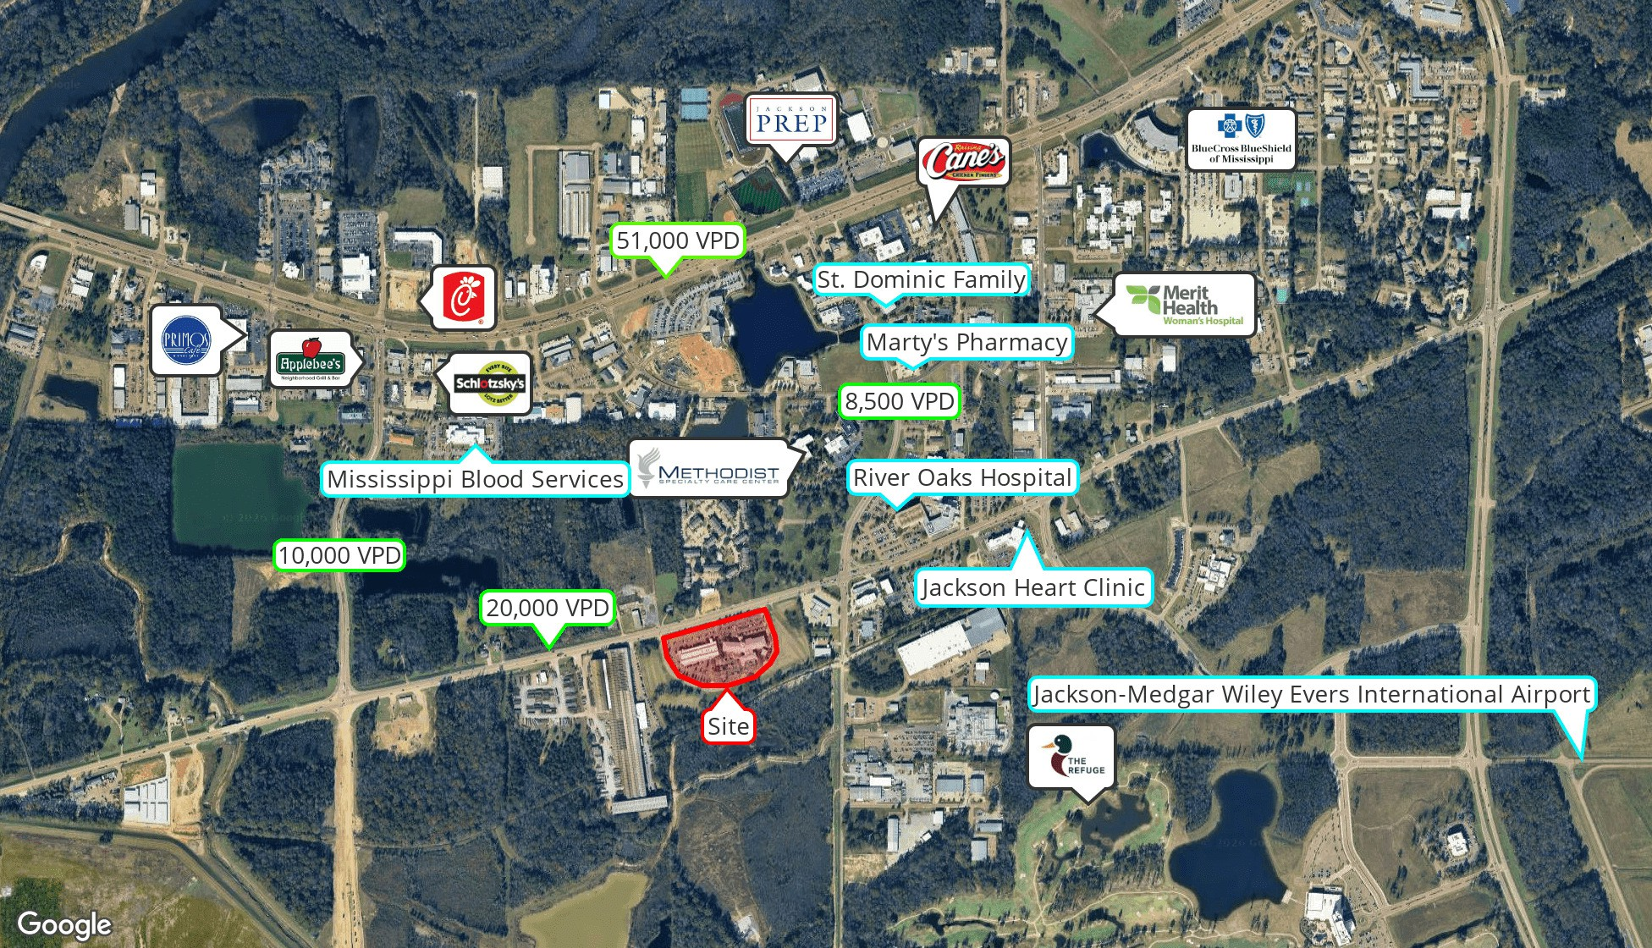

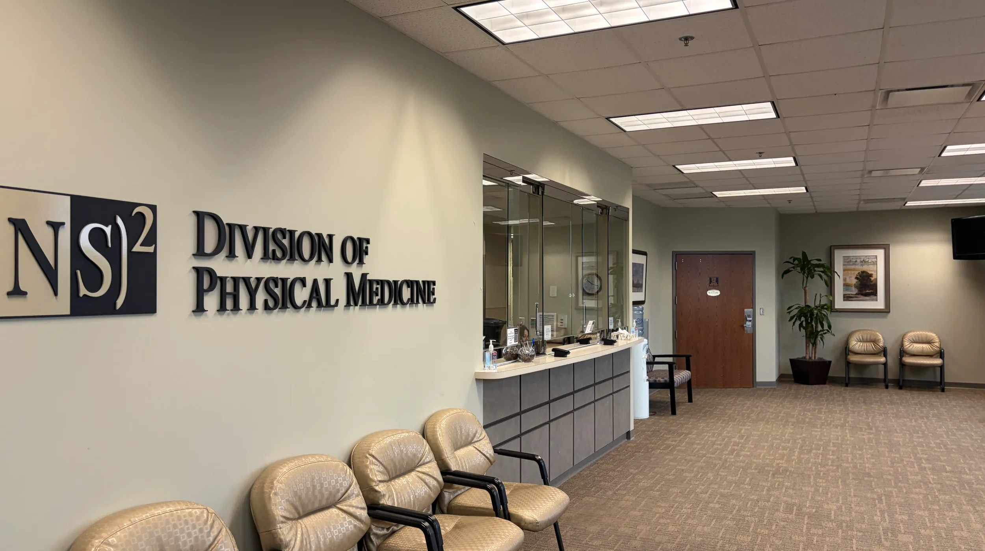
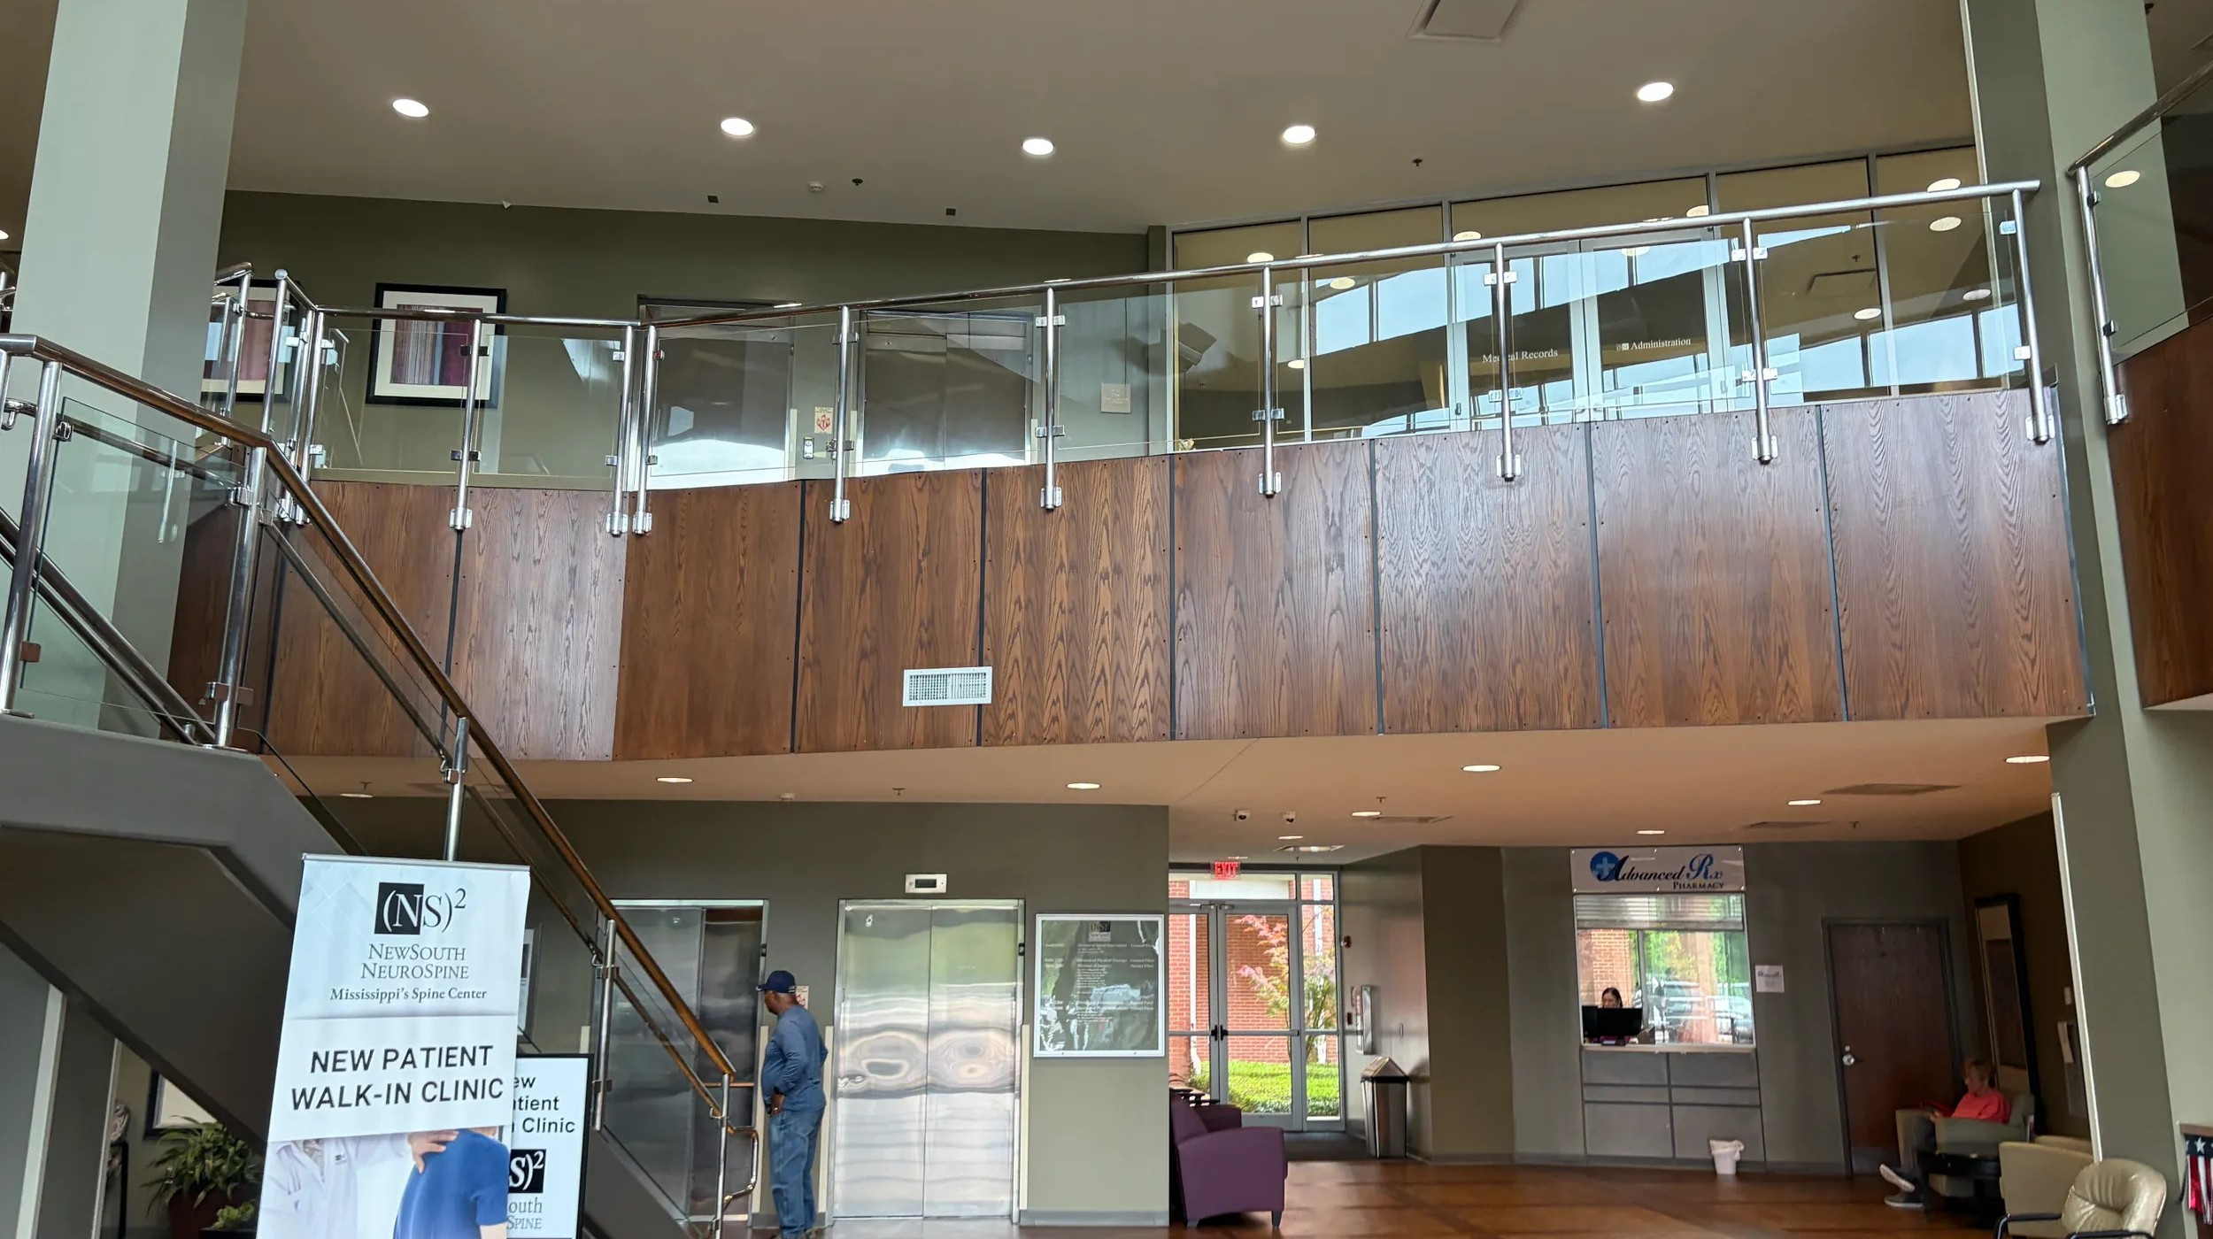
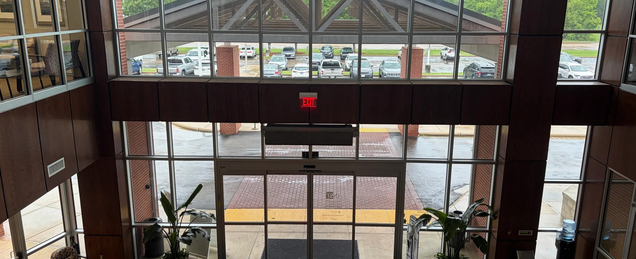
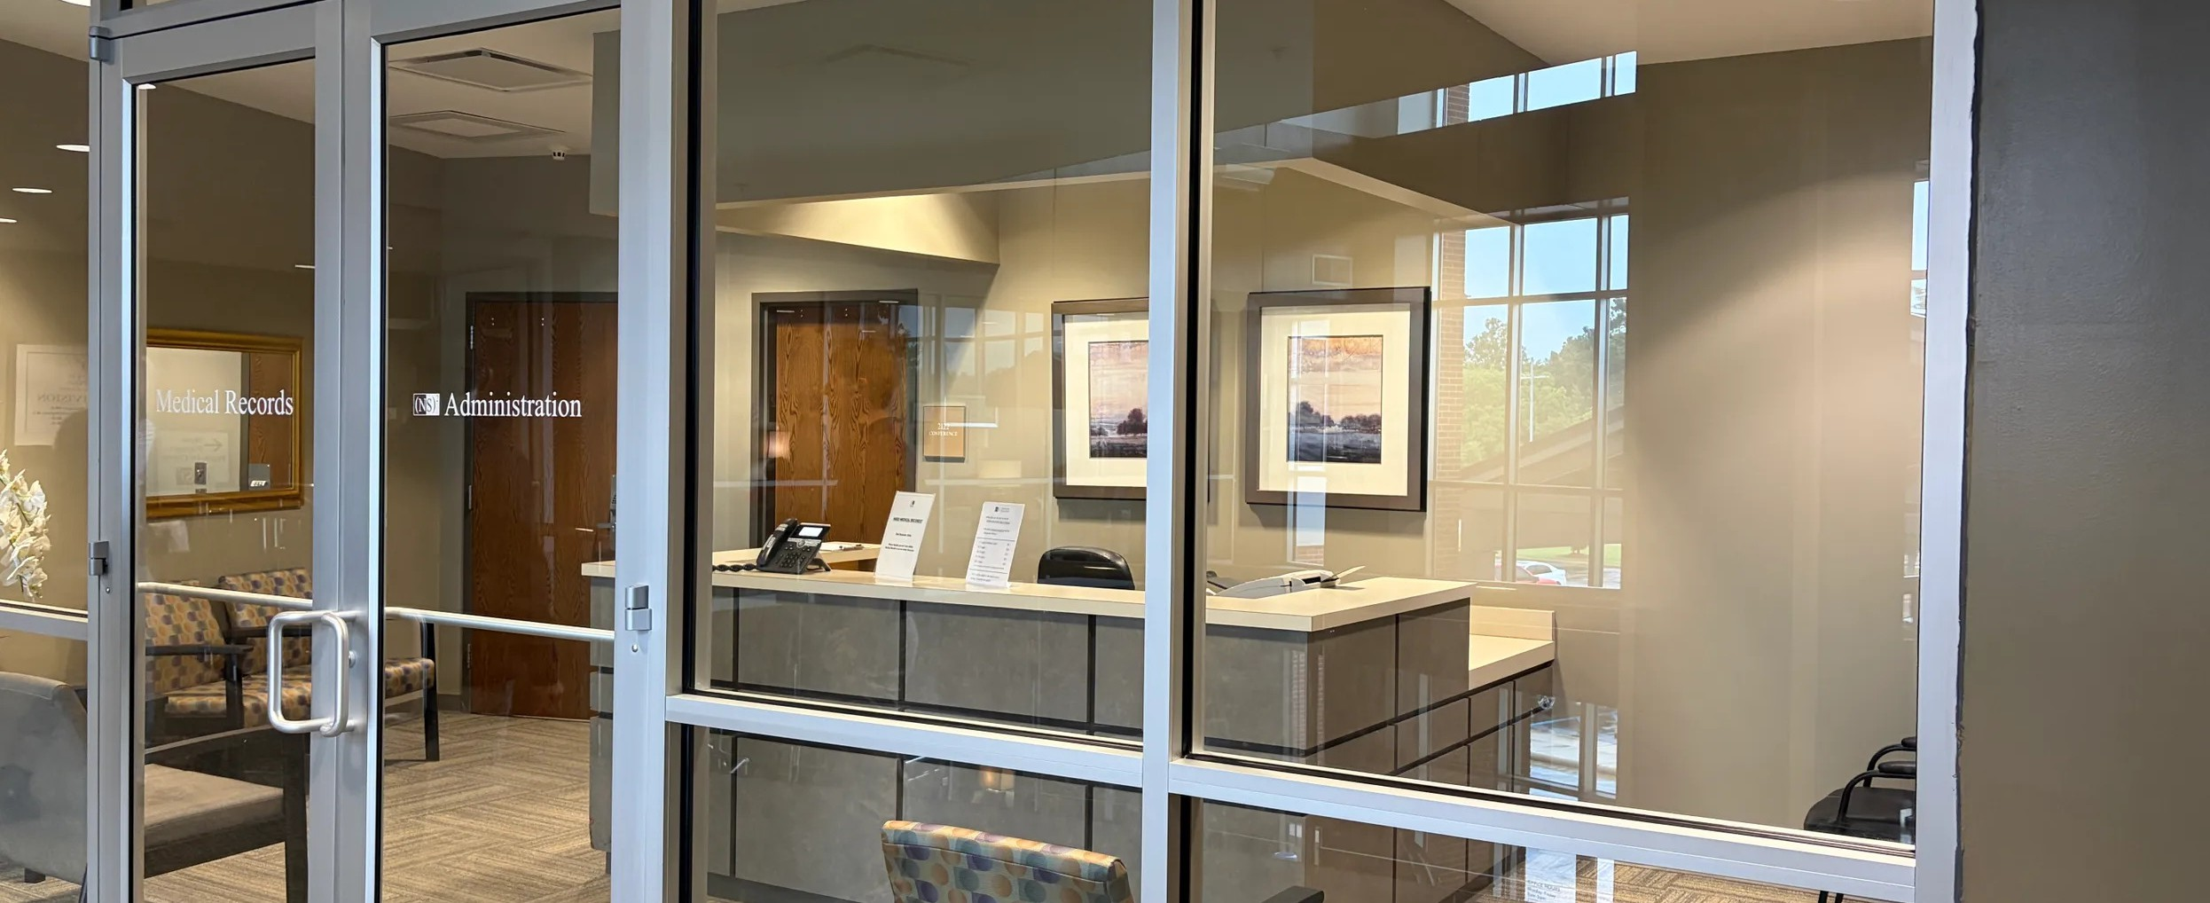
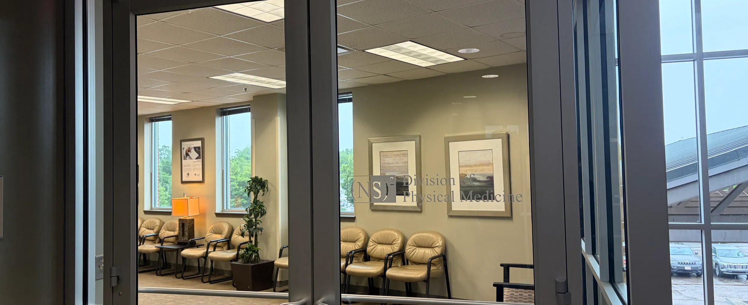
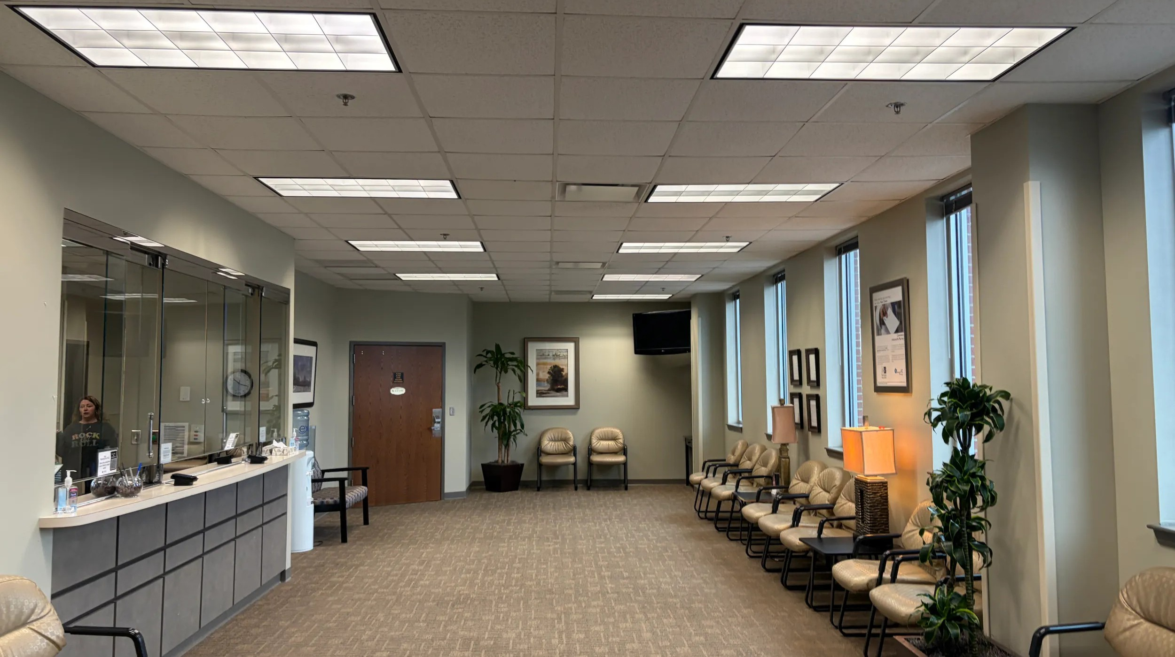
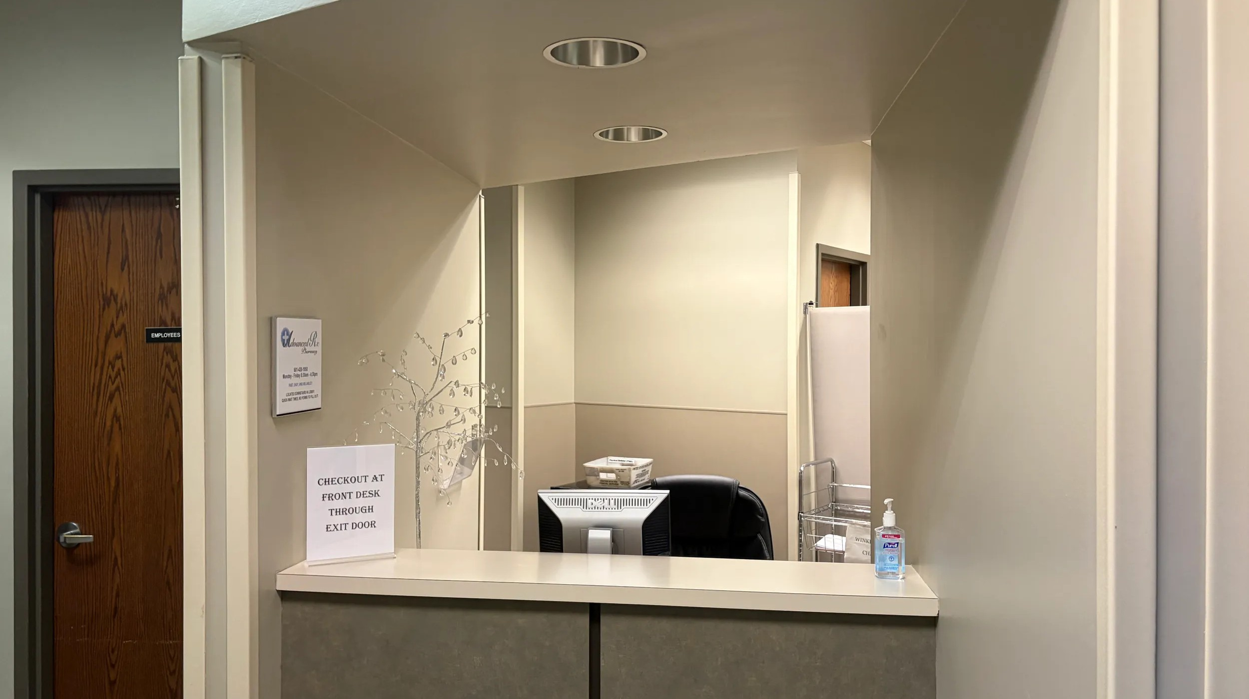
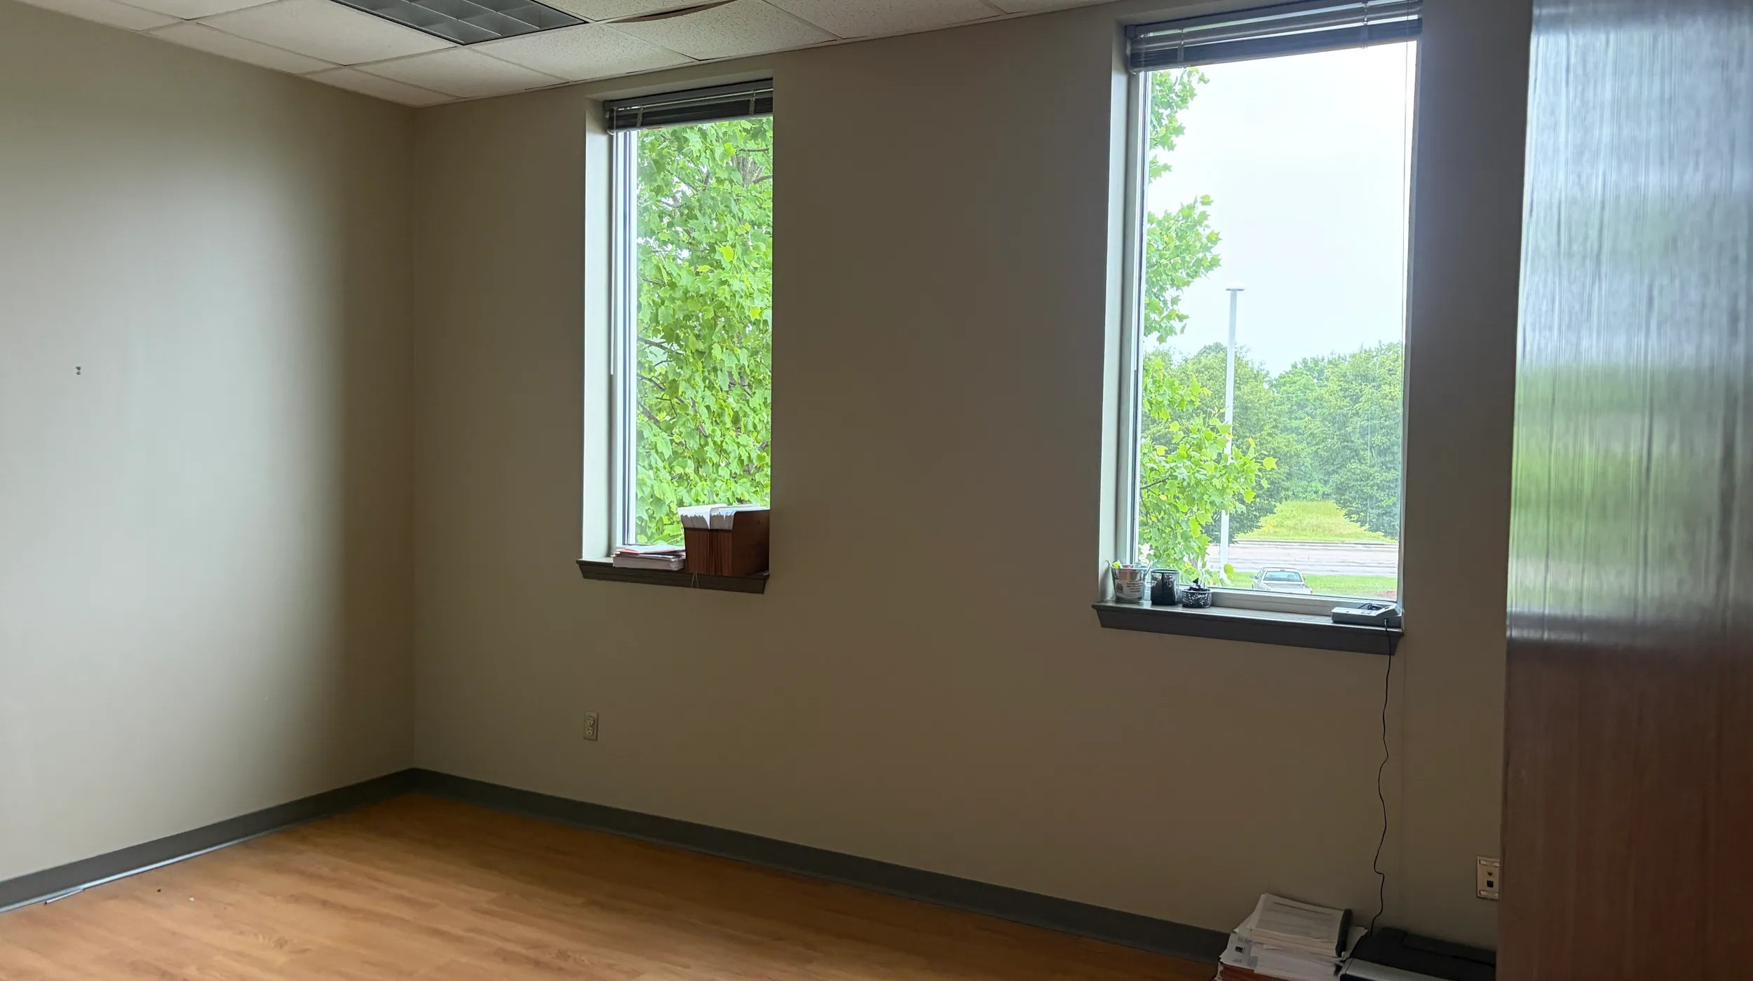
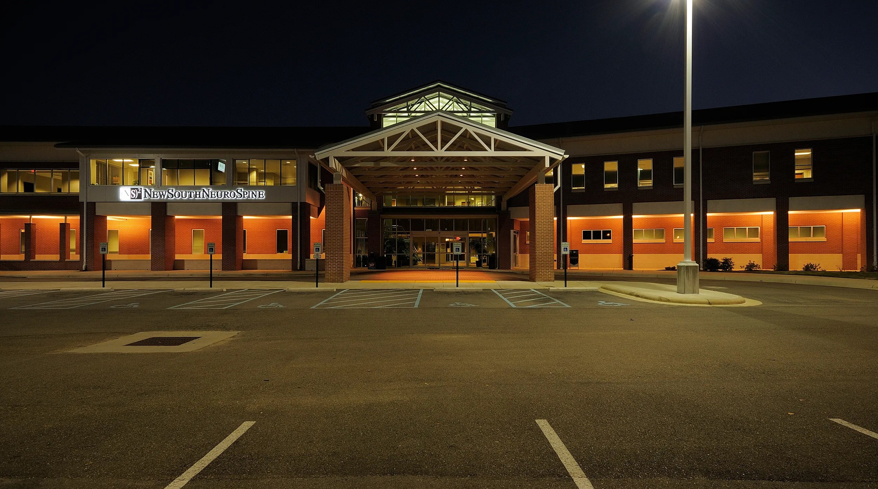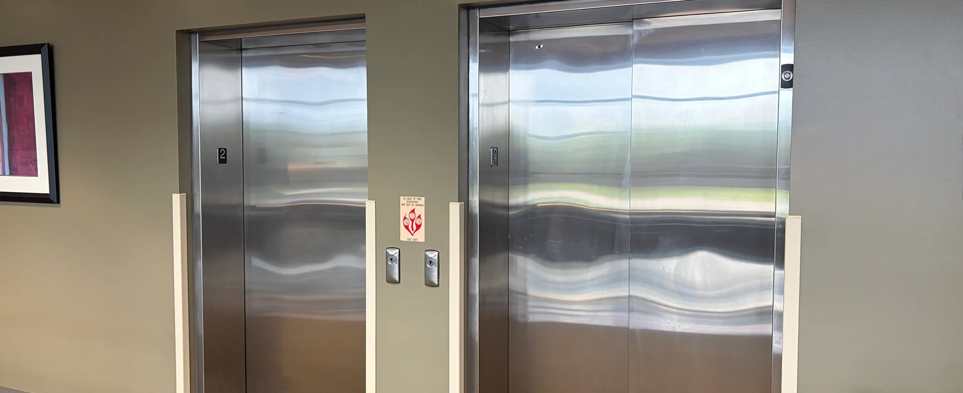

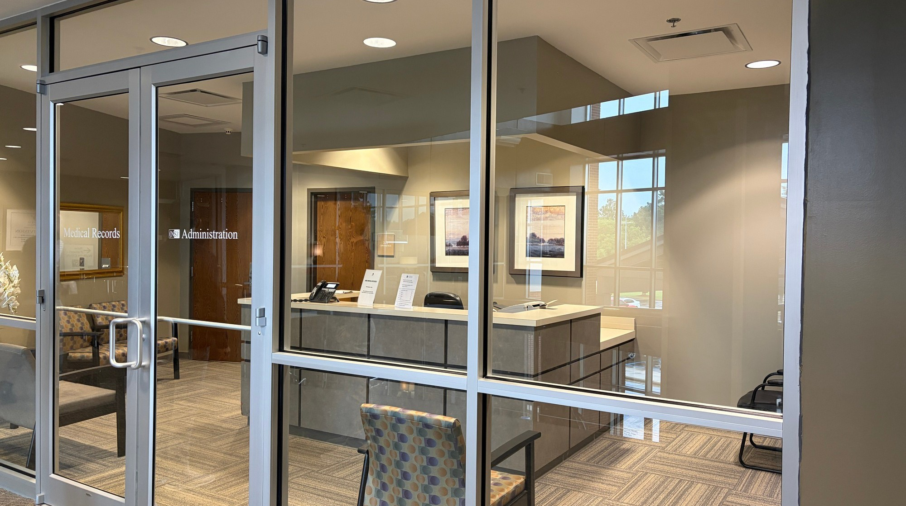
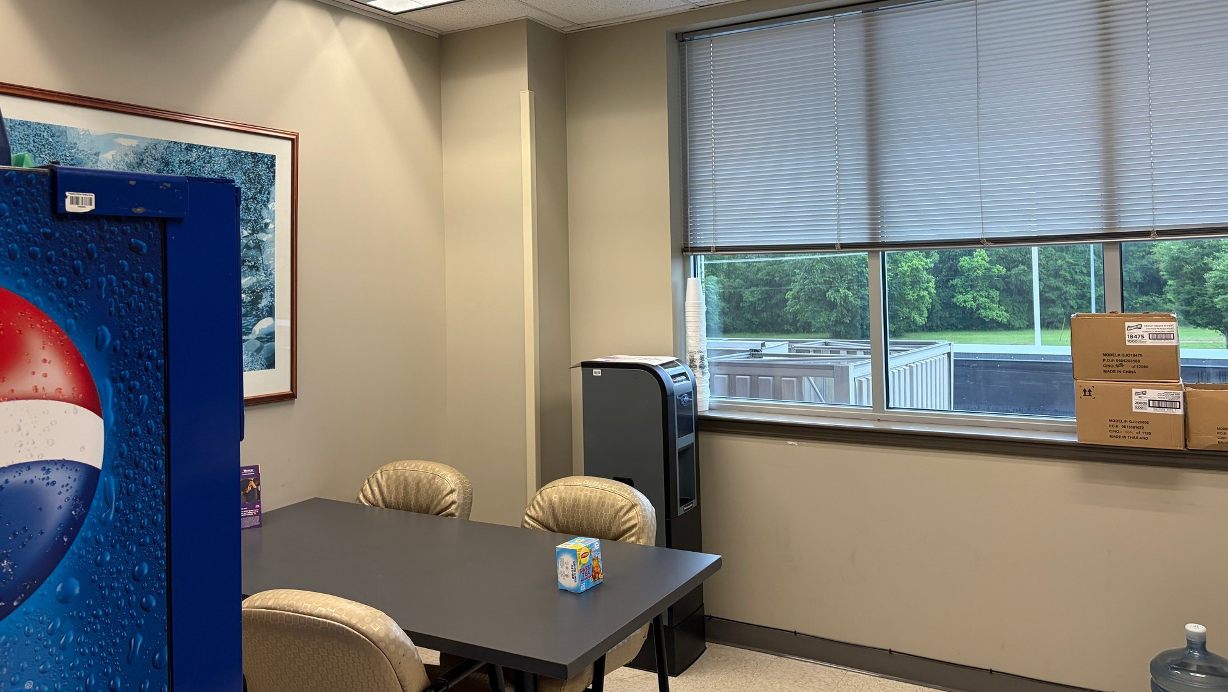
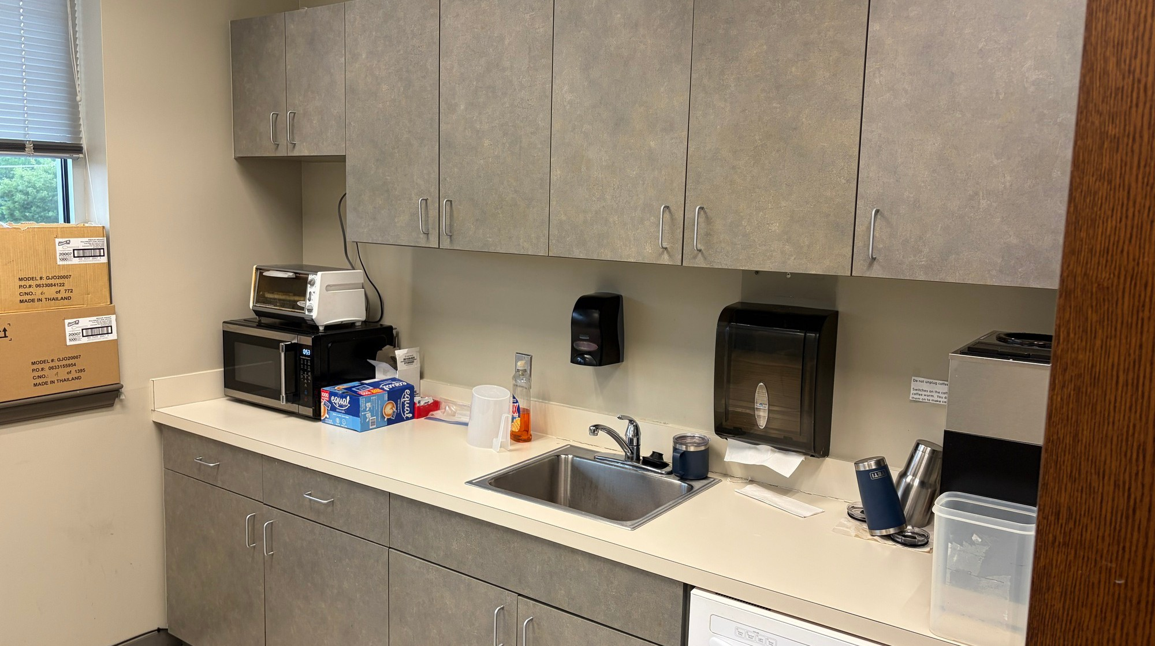
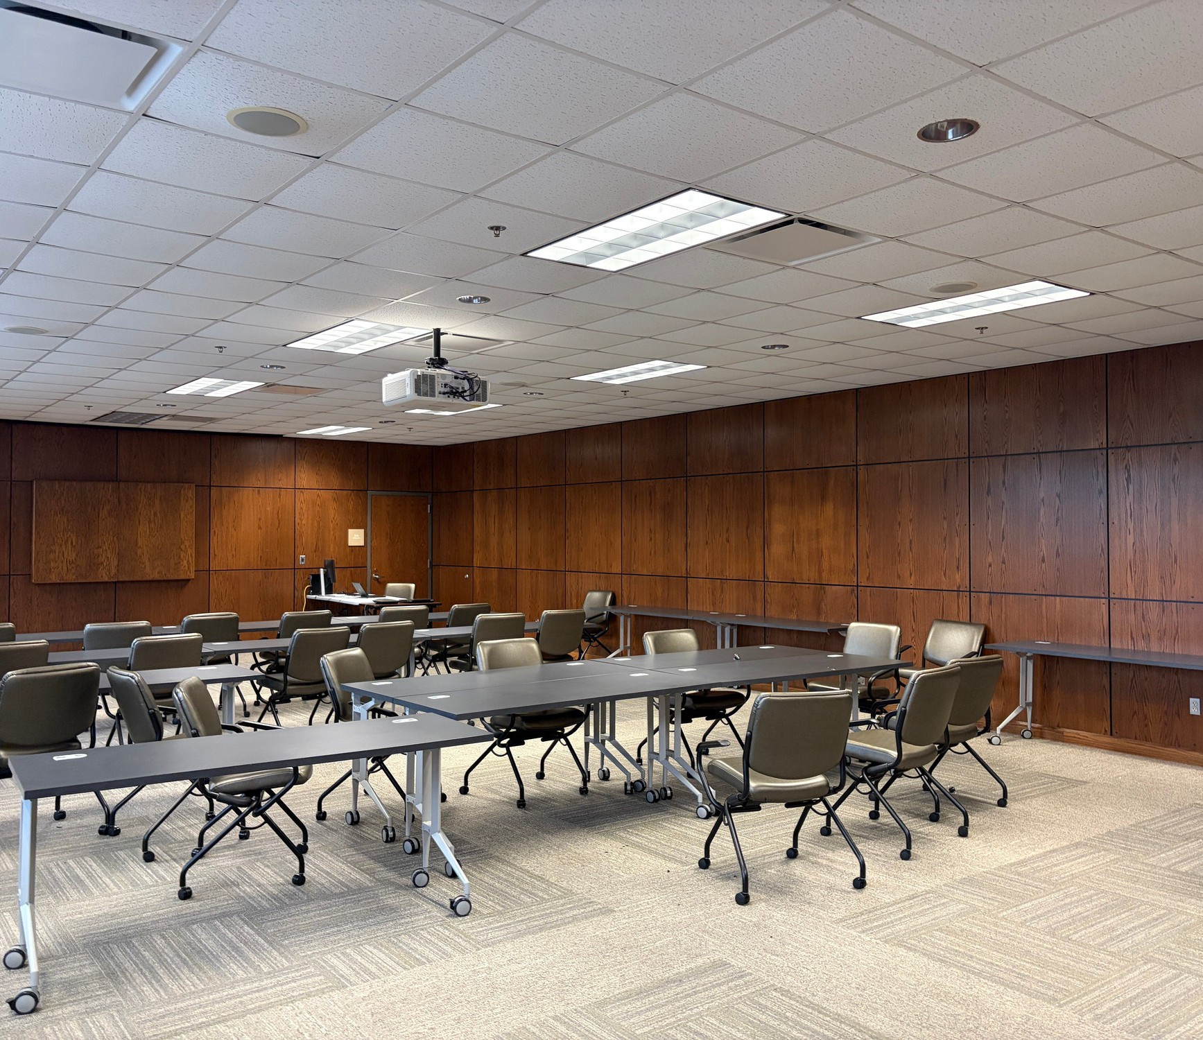
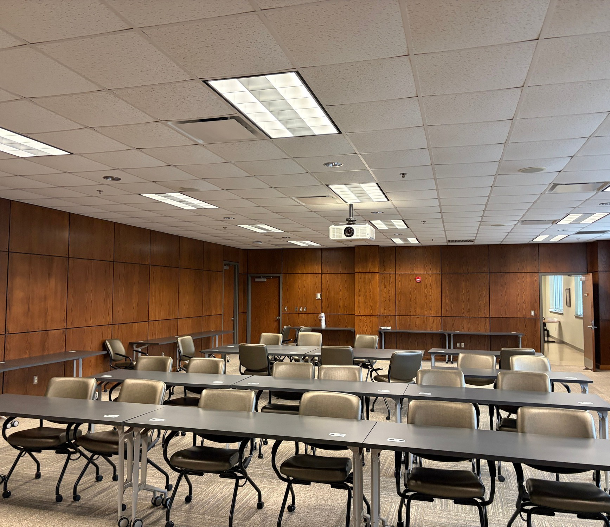
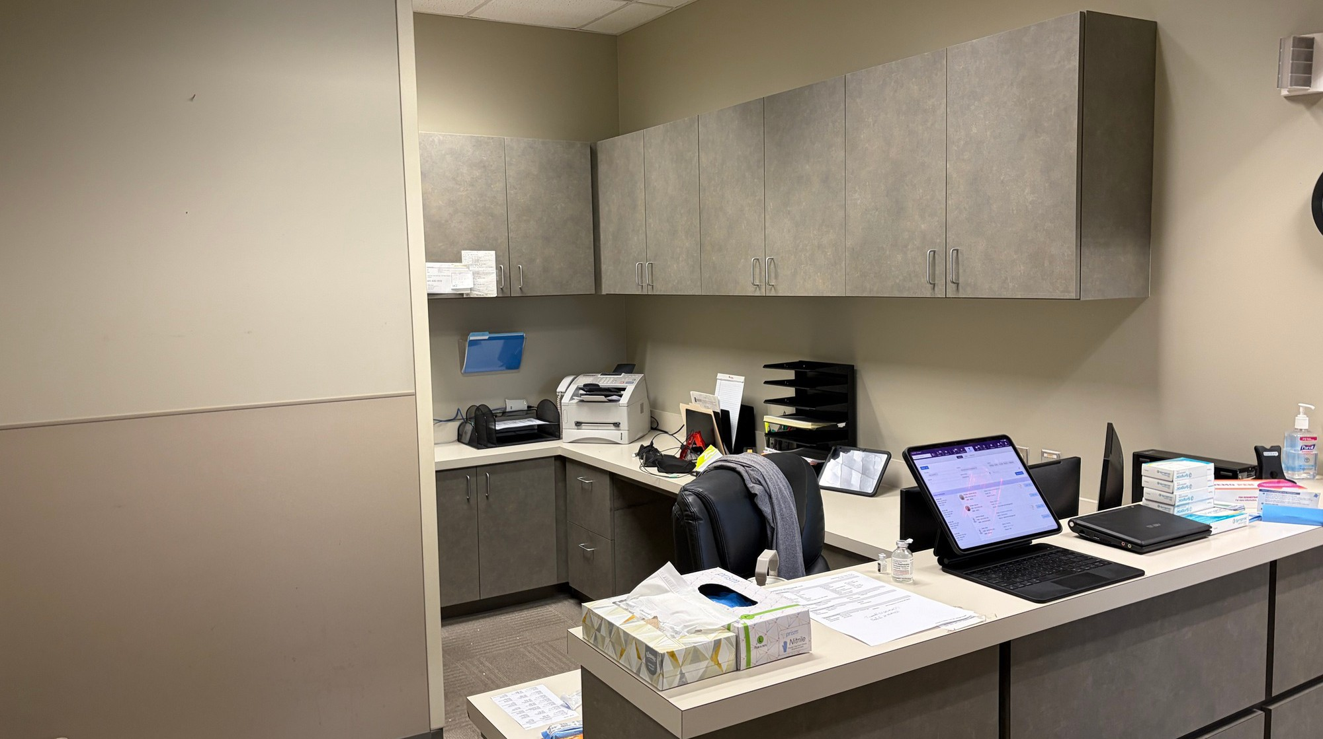
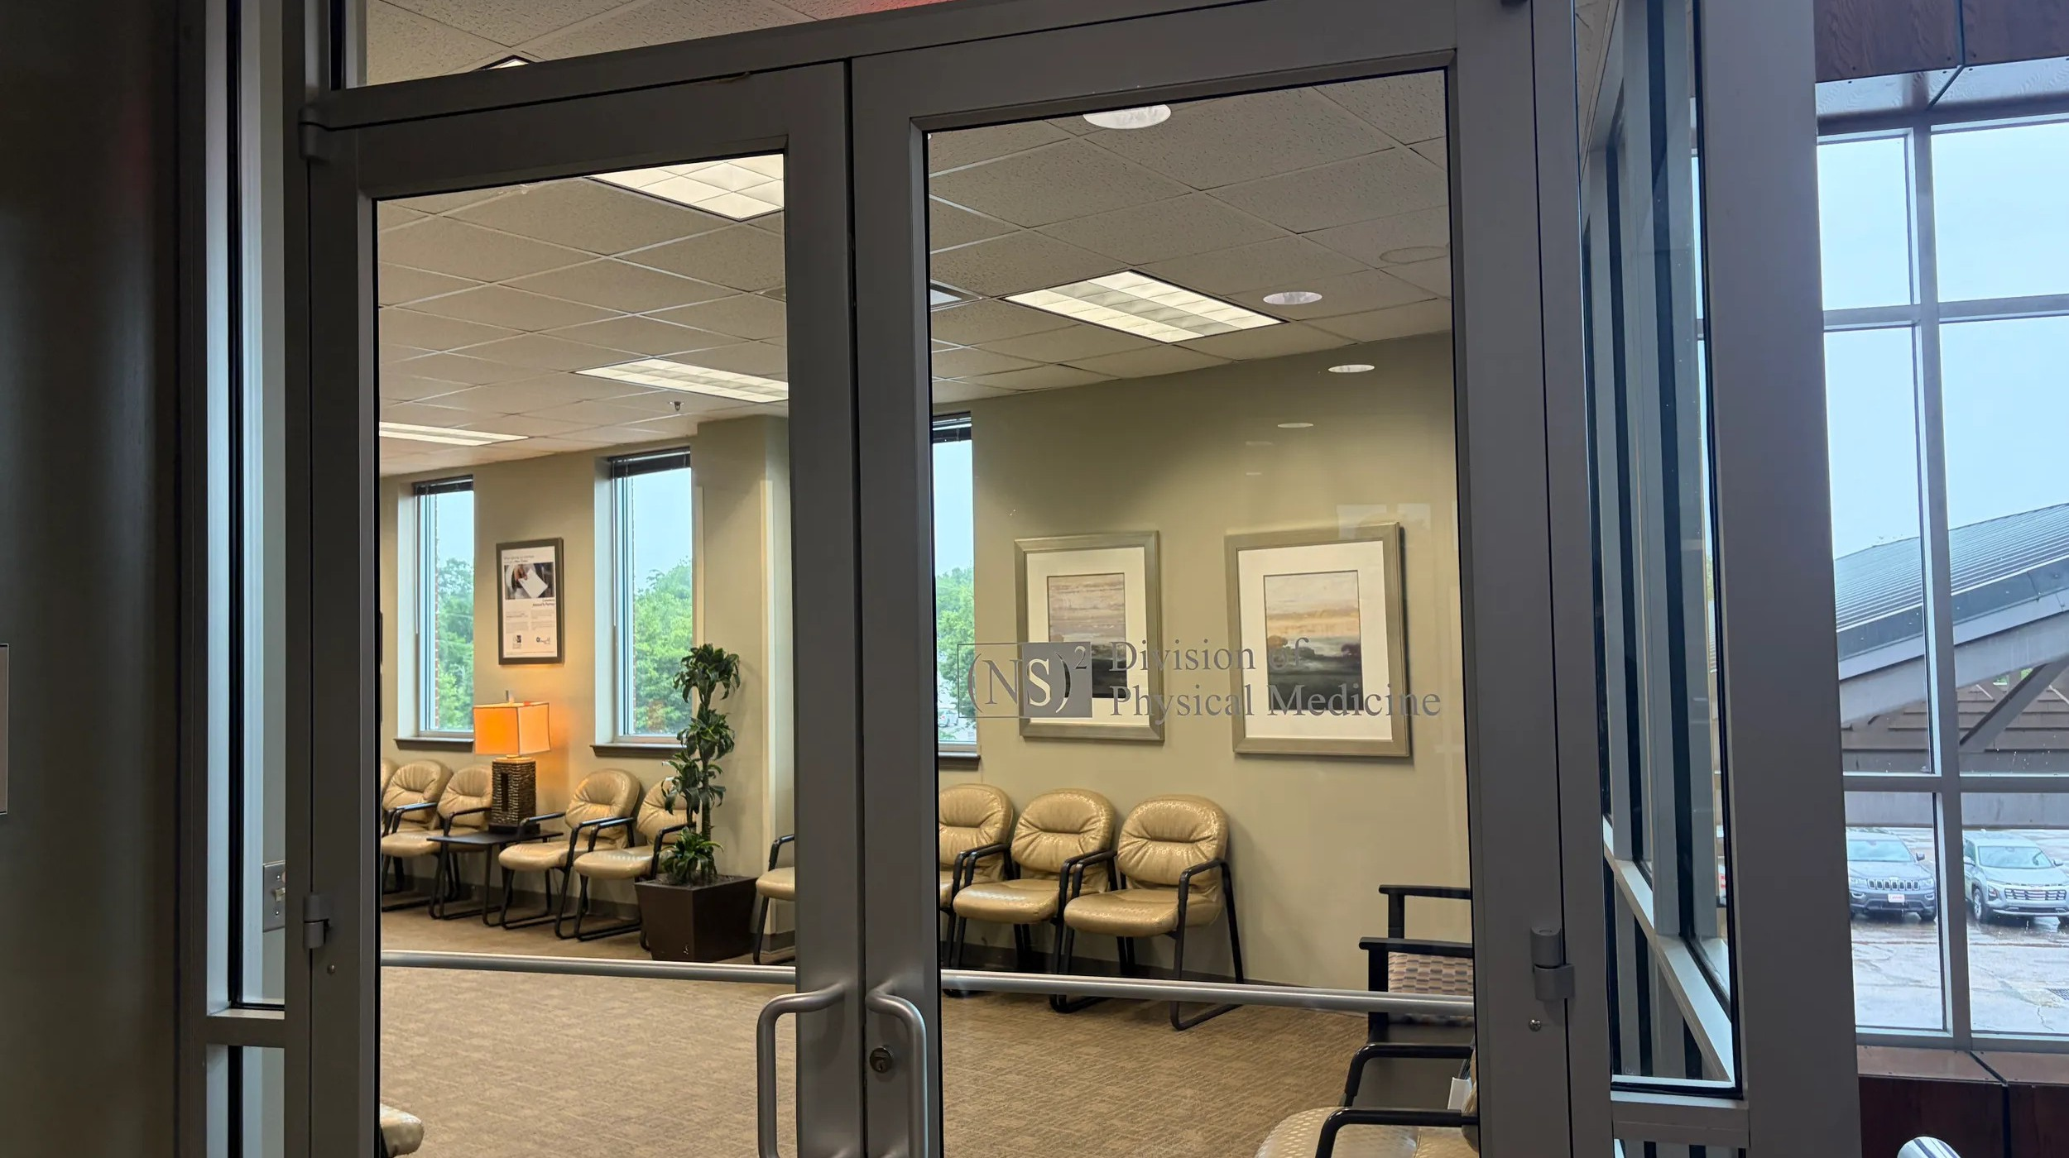
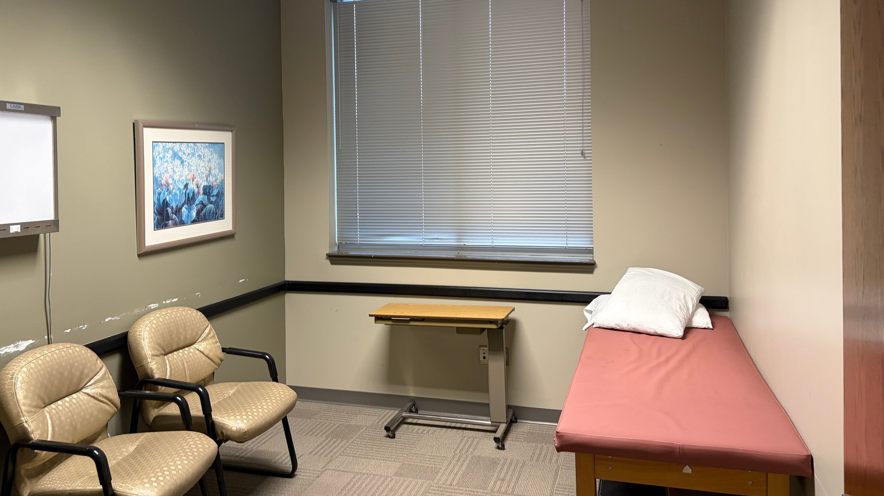

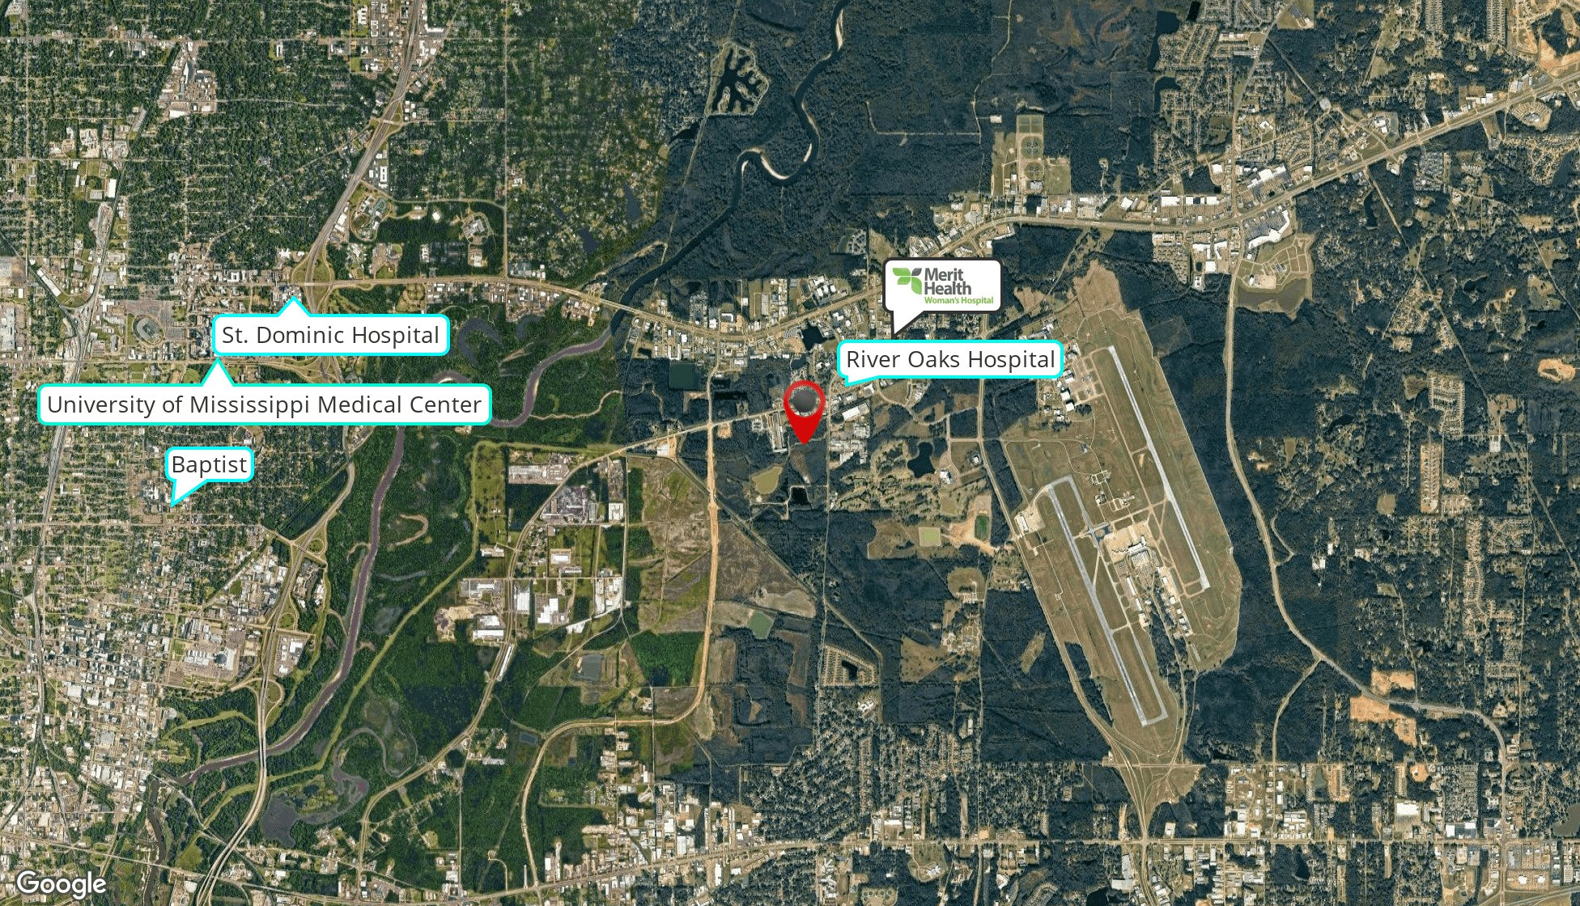

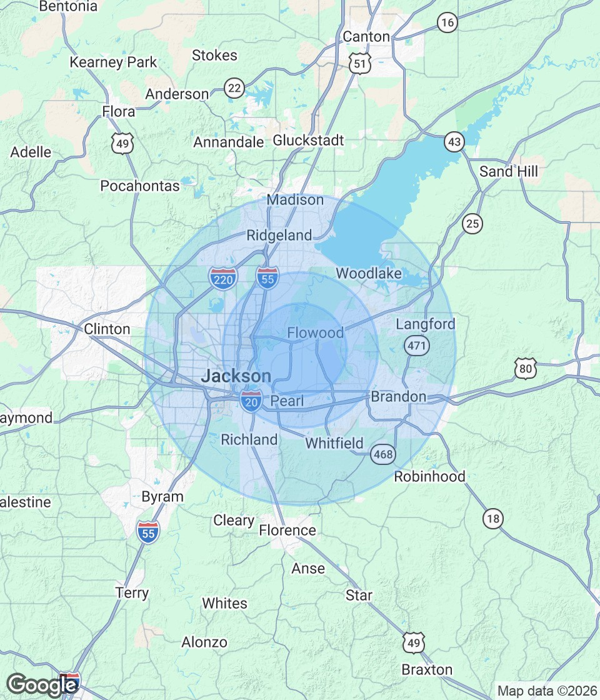
POPULATION | 3 MILES | 5 MILES | 10 MILES
Total Population | 13,465 | 83,707 | 284,009
Average Age | 39.4 | 37.7 | 38.0
Average Age (Male) | 38.6 | 37.1 | 36.7
Average Age (Female) | 40.1 | 38.3 | 39.1
HOUSEHOLDS & INCOME | 3 MILES | 5 MILES | 10 MILES
Total Households | 5,904 | 36,439 | 113,413
# of Persons per HH | 2.3 | 2.3 | 2.5
Average HH Income | $124,426 | $85,551 | $84,060
Average House Value | $341,330 | $236,532 | $226,292
2023 American Community Survey (ACS)

