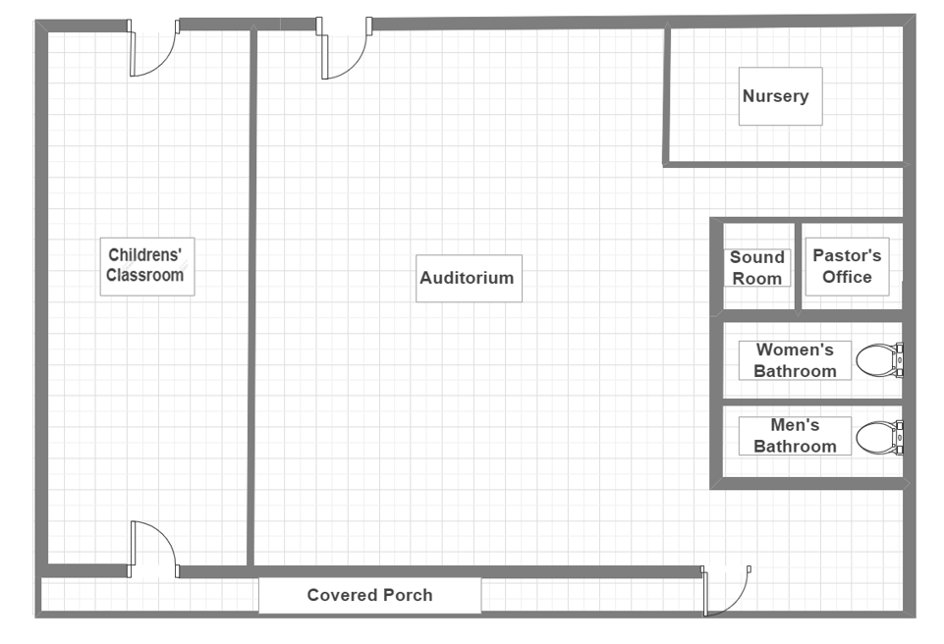
Back of Building

16’
12’
17’

35’
31’

31’

46’

75’
Front of Building

