JOLYON HOUSE, HOUNSLOW TW4 6BH
Abdul: 07449779351
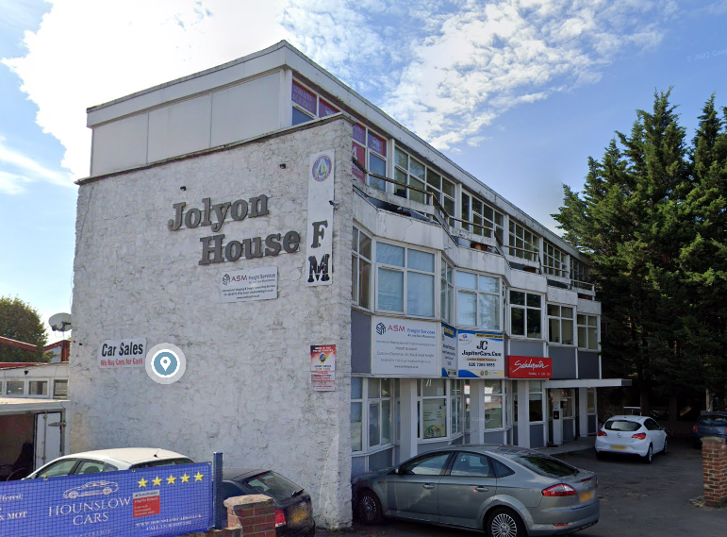

Available Space | Approx size (sq ft) | Desk Recommendation | Price Per Month ex VAT
Suite 1A | 570 | 9-10 | £1,200
Suite 1B | 250 | 4-5 | £550
Ground Floor  Suite 2B | 300 | 6 | £600

Description: Jolyon House, Hounslow is just off Green lane. Approximately 4 miles from Heathrow Airport.

Transport: The closest transport links are Hatton Cross and Hounslow West Tube Stations (Piccadilly Line and Cross Rail). Regular busses on Green Lane.

What does the above price include?

- Rent
- Service & Maintenance Charges
- Communal cleaning

Additional Costs:

- Business rates are not included although these offices should qualify for 100% rates relief but please rely on your own enquiries

