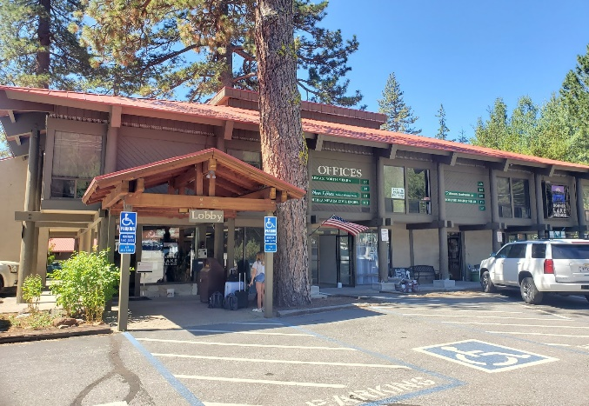
DONNER/TRUCKEE: 15695 DONNER PASS RD.
Tenant responsible for Suite Janitorial and replacement of lights.

Second Floor: Offices
Suite 204 524 Sq. Ft. +/- $1,133/month 2-year lease or
$1,234/month 1-year lease
Suite 213 321 Sq. Ft +/- $694.00/month 2-year lease or
$754.00/month 1-year lease
Suite 215 310 Sq. Ft +/- $667.00/month 2-year lease or
$729.00/month 1-year lease

Email: mdavin@davinmg.com (916) 773-1798

