

CONVENIENT SUPPORT & STORAGE SPACE
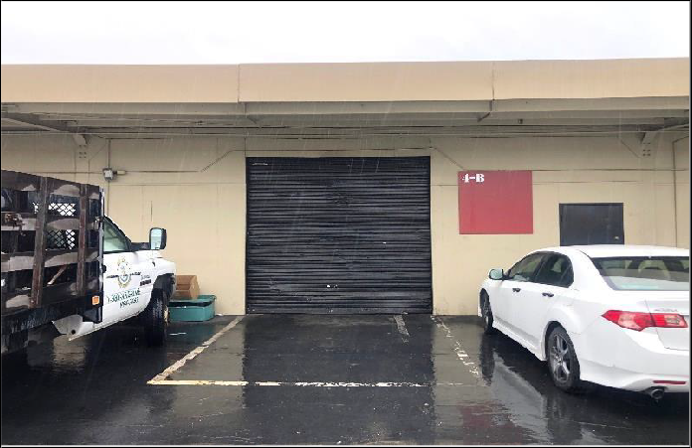
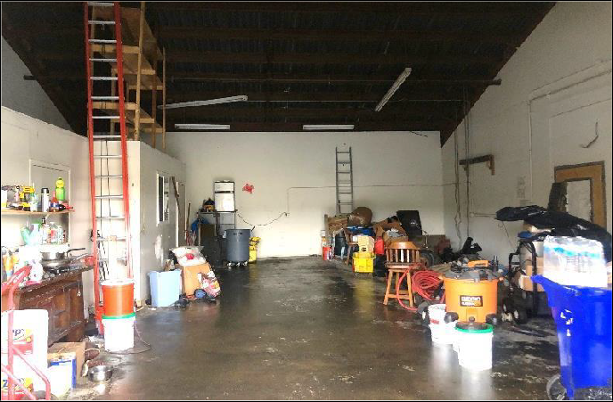
Roll-Up Door Clear-Span Storage
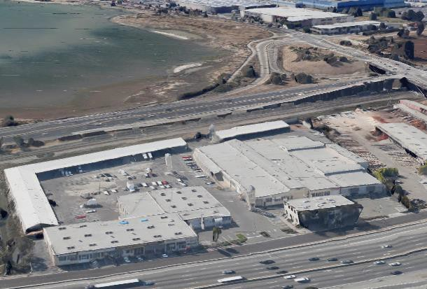





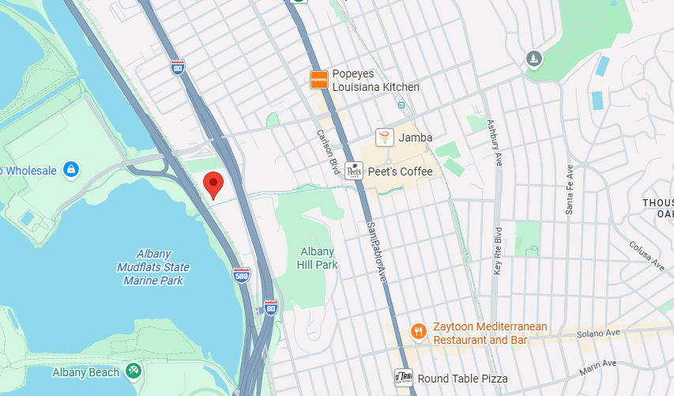

Shop Here

Site
Facing 255,000+ Captive Cars/day Convenient Location,
5 minutes from Solano Ave

I-80 SHOP SPACE FOR LEASE
5327 Jacuzzi Street #4-B: ± 1,140 Sq. Ft.
Shop or Business Service Suite with roll-up door featuring:

- Light Power
- Off Street Parking
- Direct Freeway Access
- Open Space
- Restroom Access
- Cheaper than mini-storage!
$1.49/Sq. Ft. Monthly Industrial Gross + 40¢ CAMS. Available NOW!
FOR FURTHER INFORMATION PLEASE CONTACT Todd Kollin 510/325-9714

CITY | Richmond Bayside | LISTING CO. | McNally Realty Advisors
ADDRESS | 5327 Jacuzzi Street#4-B | LISTING AGT. | Todd Kollin
CROSS ST. | Interstate 80 | PHONE # | 510/325-9714
SPACE AVAIL. | 1,140Sq. Ft. | LIST DATES | 6/26
PRICE | $2,155 / month all-in | DRE # | 982919

