1424 N Dupont Hwy, Wilmington Manor, DE 19720
$9/SF/YR
$0.75/SF/MO
Multi Use Building - $9/SF NNN
Hard Corner Retail or Office

Chris Castagno
DE DE RB -0020139
302.545.8479
Listing Added: 03/18/2022
Listing Updated: 06/25/2025

Building Details
Property TypeOffice, Retail
SubtypeTraditional Office, Event Space
TenancySingle
Total Building SqFt9,430
Vacant SqFt9,430
Land Acres0.37
Year Built1955
Buildings1
Stories2
ZoningCR - Commercial Regional
APN1001400010
Building Description
SHORT TERM LEASE AVAILABLE
ONLY $9/SF for space in AS - IS, WHERE - IS condition.​
Former Wells Fargo retail bank and office space.​
All brick exterior with pylon signage opportunity.​
Highly visible signalized intersection - part of Continental Shopping Center
Approx.​ 52,000 VPD on Dupont Hwy.​
Plenty of parking at building and lots of shared parking with Shopping Center
Currently fit out as grocery with second floor office space.​ Tenant may modify as needed.​
NO Commercial kitchen currently inside.​
Prefer single tenant - possible multi tenant 1 per floor with shared utilities - utilities not demised.​
4,715SF per floor
$25,000 Security Deposit and Personal Guarantee Required.​ Due at Lease Commencement.​
3% Annual Rental Rate increases.​
$15,771 Annual Property Taxes.​ Tenant responsible for a proportionate of annual amount due at Lease Commencement.​
Monthly Rent: $7,072.50.​ NNN
CAM: $1,610/Mo.​ ($2.05/SF)
Tenant Responsible for:
G/L Insurance
All Utilities including Sewer
Property Taxes

Building Location (1 Location)
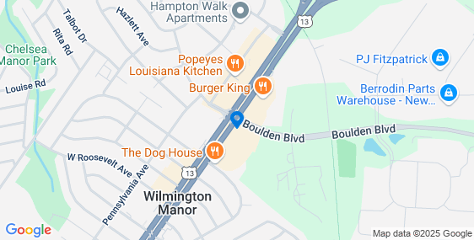
Details
Listing TypeDirect
RSF9,430 SF
USF9,430 SF
Rate (Per SF)$9 / SF / YR
Lease TypeNNN
Lease term2-4 years
Total Rate (Per SF/YR)$9
Days on Market373 days
Property Photos (2 photos)
